Git Commands Execution
1. git init: Initializes a new Git repository in the current directory.
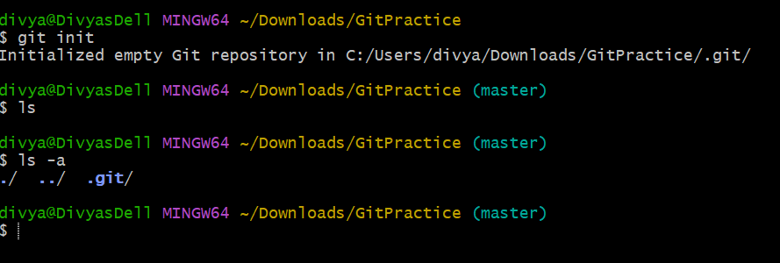
2. git clone <repo_url>: Clones a repository from a remote URL to your local machine.
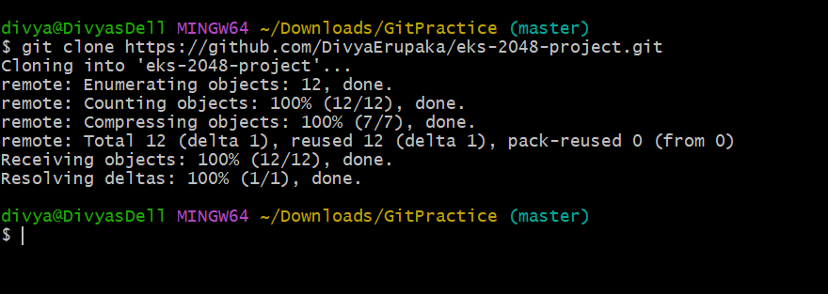
3. git status: Shows the working directory status (which files are modified, staged, etc.)
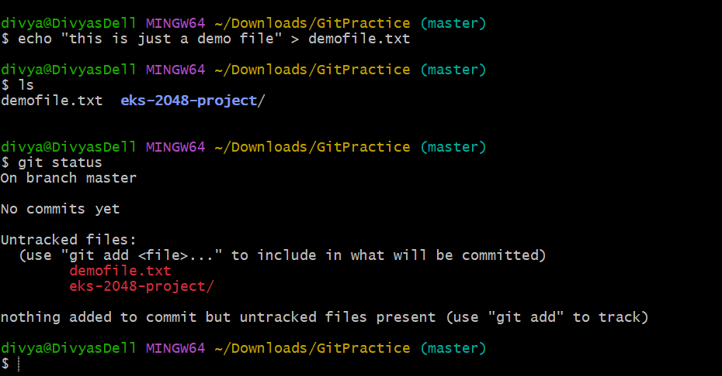
4. git add: Stages a file or files to be committed.
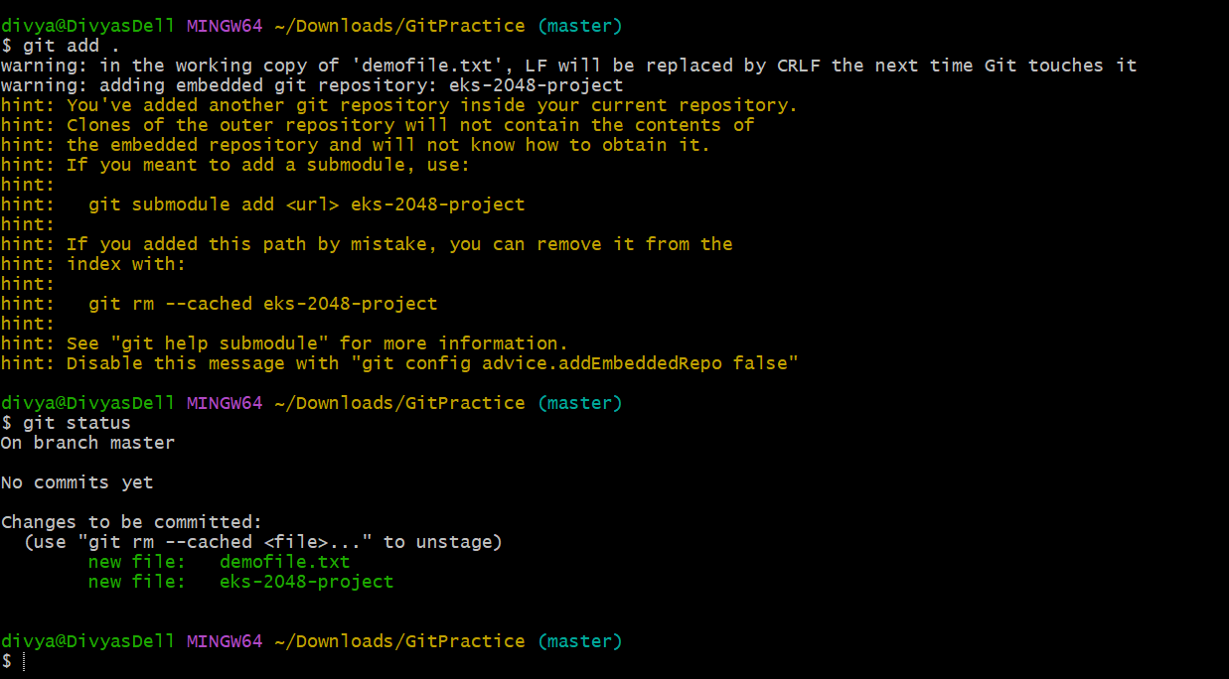
5. git commit -m "message": Commits staged changes to the local repository with a message.
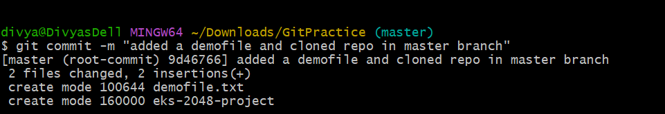
6. git push: Pushes committed changes to the remote repository.
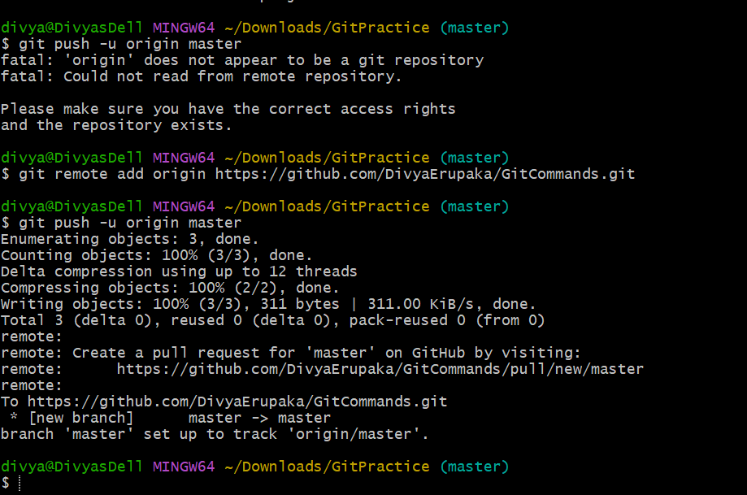
7. git pull: Fetches and merges changes from the remote repository to your local working directory.
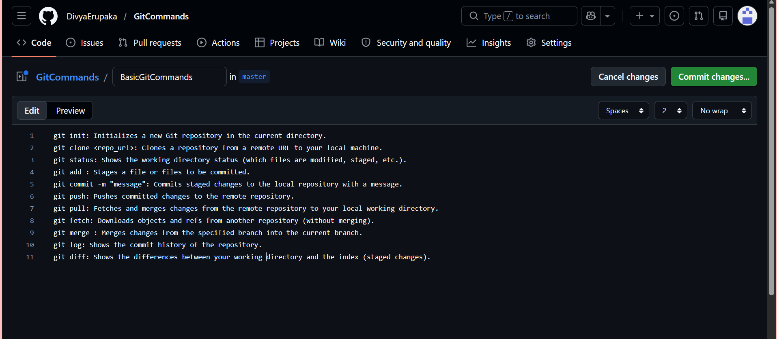
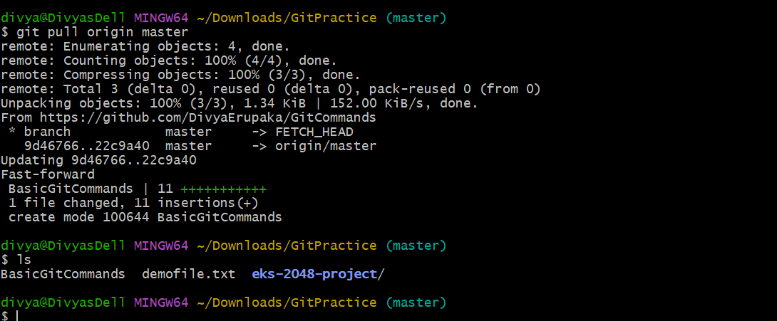
8. git fetch: Downloads objects and refs from another repository (without merging).
Overview
git fetch is used to download commits, branches, and references from a remote repository without merging them into the current branch.
It updates the remote-tracking branches, such as:
origin/master
origin/main
In this task, changes were made in the central repository (README.md updated on GitHub), and the local repository fetched those updates successfully.
Objective : To fetch the latest changes from the central repository and verify that the updates are available locally without automatically merging them.
Prerequisites
- Git installed
- Repository cloned locally
- Remote repository configured (origin)
- Internet connection
Steps Performed
Step 1: Navigate to Local Repository
cd ~/Downloads/GitPractice
Outcome
Successfully moved into the local Git repository.
Step 2: Fetch Changes from Remote Repository
git fetch origin
Output
remote: Enumerating objects: 4, done.
remote: Counting objects: 100% (4/4), done.
remote: Compressing objects: 100% (2/2), done.
remote: Total 3 (delta 1), reused 0 (delta 0), pack-reused 0
Unpacking objects: 100% (3/3), 963 bytes
From https://github.com/DivyaErupaka/GitCommands
22c9a40..92b4f9b master -> origin/master
Outcome
- Remote changes were downloaded successfully.
- origin/master was updated from commit:
22c9a40 -> 92b4f9b
- No local files were modified automatically.
Step 3: Verify Fetched Commits
git log HEAD..origin/master --oneline
Expected Output
92b4f9b Updated README file
Outcome : Verified that new commits exist in the remote branch and are not yet merged into the local branch.
Step 4: pull Remote Changes (Optional) : git pull origin master
Validation
Validation 1: Check Remote Tracking Branch
git branch -a
Expected Result
* master
remotes/origin/master
Confirms remote branch tracking is available.
Validation 2: Verify README Changes
cat README.md
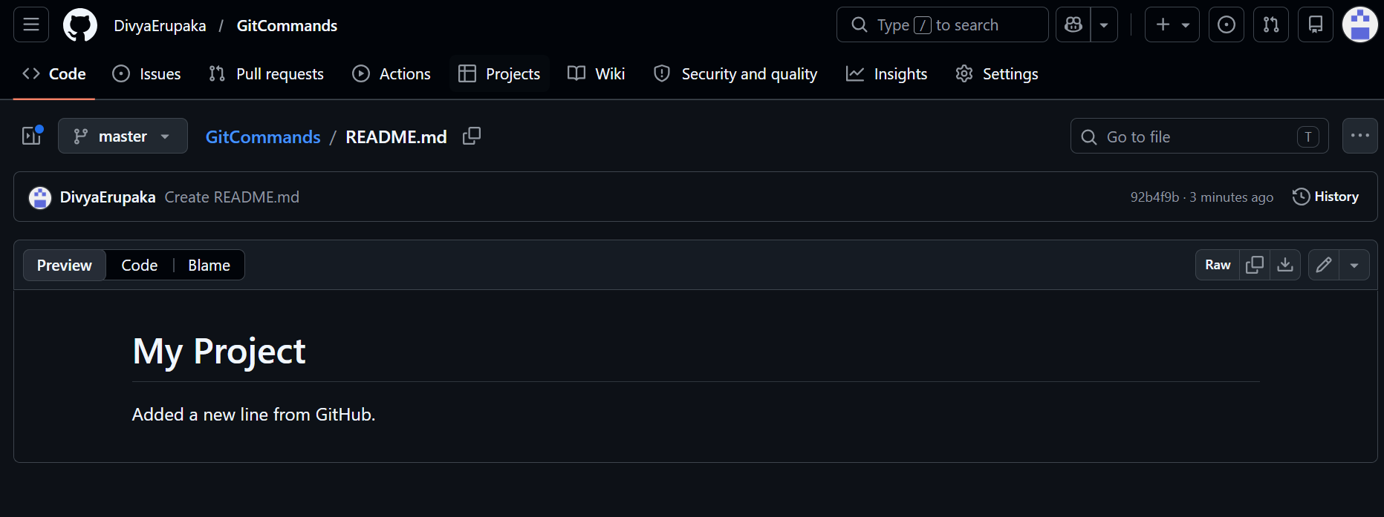
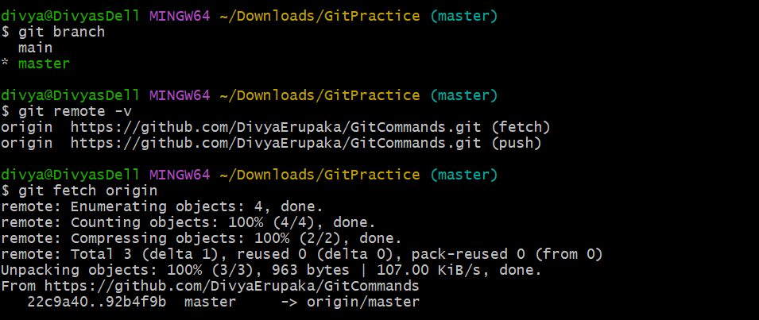
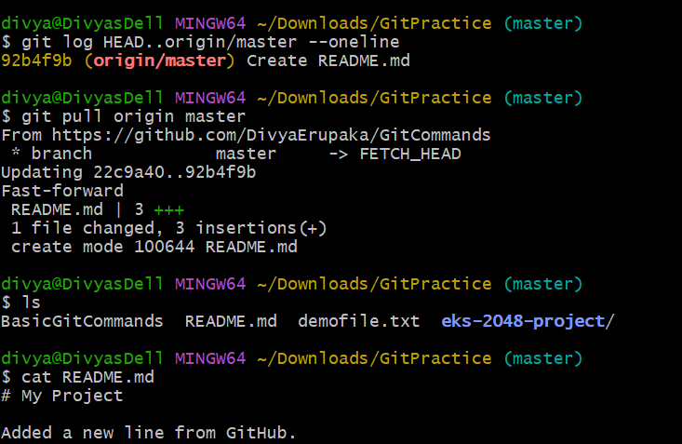
9. git merge: Merges changes from the specified branch into the current branch.
Overview: git merge combines changes from one branch into another.
Objective: To test and understand how git merge integrates changes from one branch (develop) into another branch (master).
Prerequisites
- Git installed
- Repository initialized or cloned
- Access to terminal/Git Bash
- Remote repository configured (origin)
Steps Performed
Step 1: Navigate to Repository
cd ~/Downloads/GitPractice
Outcome
Moved into the local Git repository.
Step 2: Create a New Branch
git branch develop
Outcome
Created a new branch named develop.
Step 3: Switch to Develop Branch
git checkout develop
Expected Output
Switched to branch 'develop'
Outcome
Successfully switched from master branch to develop branch.
Step 4: Create Files Using Touch Command
touch f1 f2
Step 5: Verify Created Files: ls
Step 6: Add Files to Staging Area: git add .
Step 7: Commit Changes: git commit -m "Added f1 and f2 files in develop branch"
Step 8: Push Develop Branch to Central Repository: git push origin develop
Step 9: Switch Back to Master Branch
git checkout master
Expected Output
Switched to branch 'master'
Outcome
Returned to the master branch.
Step 10: Verify Files Before Merge
ls
Expected Result
Files f1 and f2 should not appear in the master branch before merge.
Step 11: Merge Develop Branch into Master: git merge develop
Outcome
- Changes from develop branch merged successfully into master
- Files f1 and f2 became available in master branch
Step 12: Verify Files After Merge ls
Expected Output
f1 f2
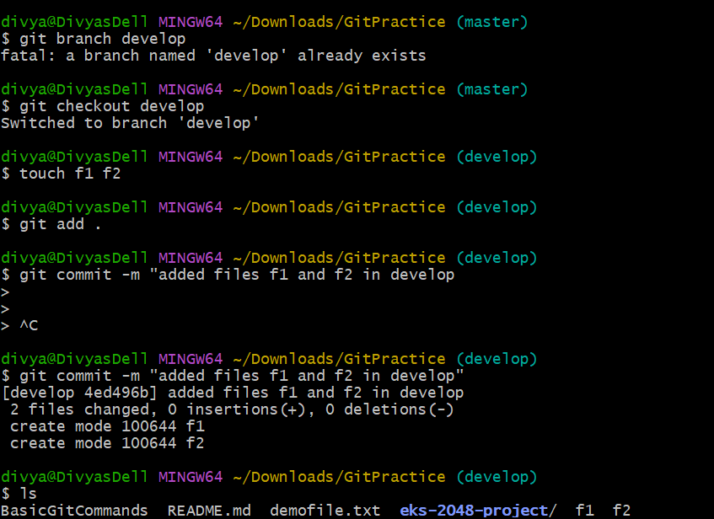
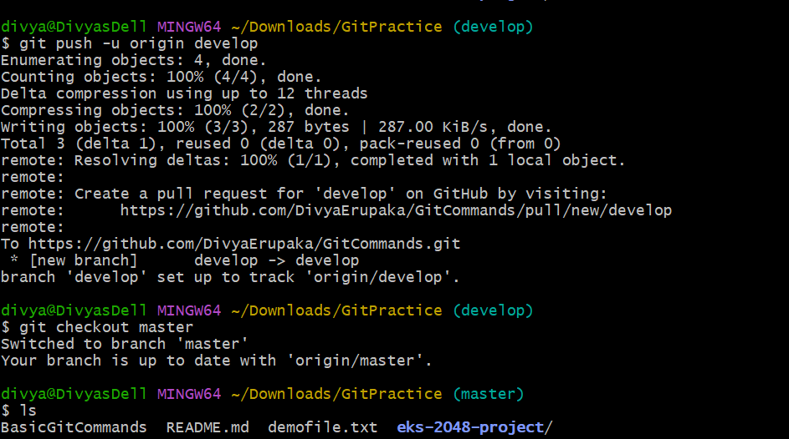
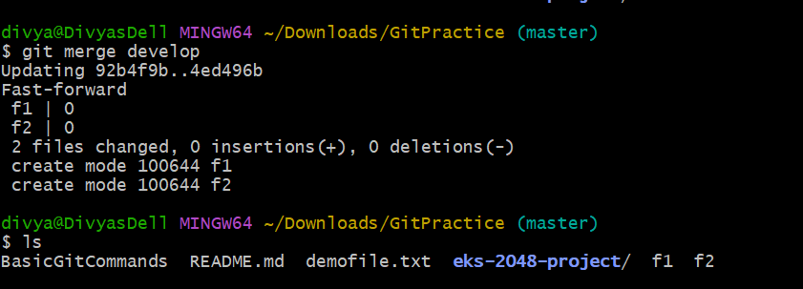
10. git log: Shows the commit history of the repository.
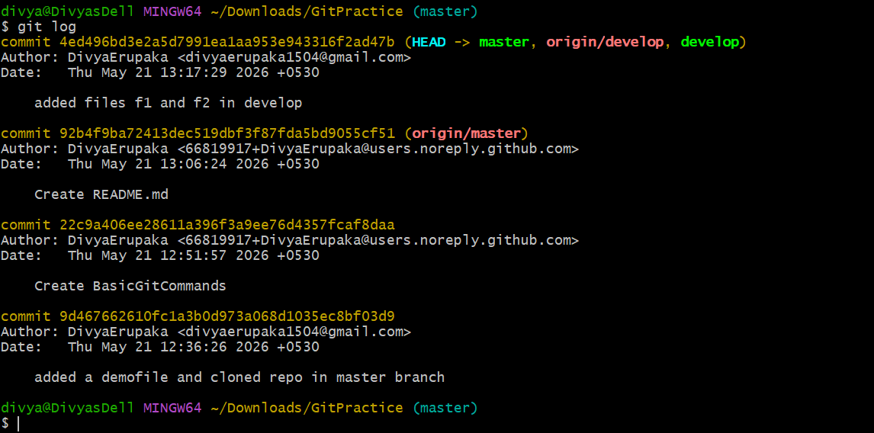
11. git diff: Shows the differences between your working directory and the index (staged changes).
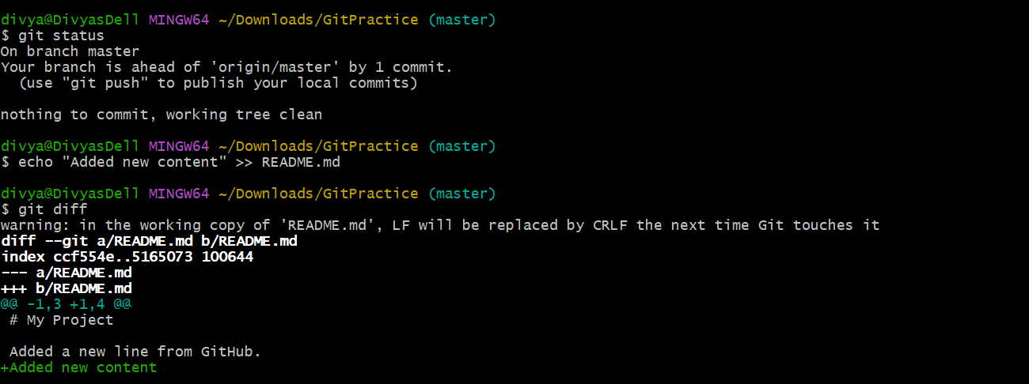
Branching Commands (Managing branches)
1. git branch: Lists all branches in your repository.
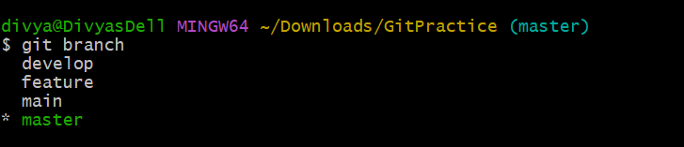
2. git branch <branch_name>: Creates a new branch
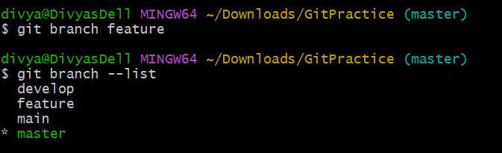
3. git checkout <branch_name>: Switches to an existing branch.
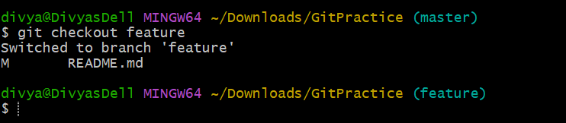
4. git checkout -b <branch_name>: Creates and switches to a new branch in one step.
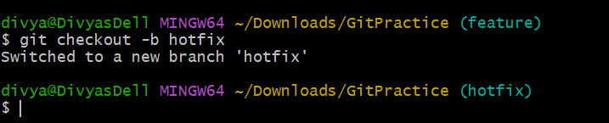
5. git merge <branch_name>: Merges changes from the specified branch into the current branch.
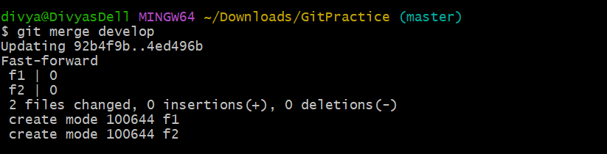
6. git rebase <branch_name>: Applies changes from one branch onto another branch (instead of merging).
Overview: git rebase applies commits from one branch to another, instead of creating a merge commit.
It rewrites the commit history and creates a linear project history.
Example: git rebase develop
This applies the current branch changes to the develop branch.
Objective: To understand and perform branch integration using git rebase instead of git merge.
Prerequisites
- Git installed
- Repository initialized or cloned
- Multiple branches available
- Commits present in both branches
Scenario
- A branch named develop contains new commits.
- The master branch contains separate commits.
- git rebase develop is used from the master branch to place master commits on top of develop branch history.
Steps Performed
Step 1: Navigate to Repository
cd ~/Downloads/GitPractice
Step 2: Check Available Branches
git branch
Expected Output
develop
* master
Outcome
Confirmed available branches and current active branch.
Step 3: Switch to Develop Branch
git checkout develop
Outcome
Switched to develop branch.
Step 4: Create and Commit Changes in Develop Branch
touch f1
git add .
git commit -m "Added file f1 in develop branch"
Outcome
Created and committed new changes in develop branch.
Step 5: Switch Back to Master Branch
git checkout master
Outcome
Returned to master branch.
Step 6: Create Separate Changes in Master Branch
touch f2
git add .
git commit -m "Added file f2 in master branch"
Outcome
Created independent commit in master branch.
Step 7: Rebase Master onto Develop
git rebase develop
Expected Output
Successfully rebased and updated refs/heads/master.
Outcome
- Commits from master branch were replayed on top of develop
- Linear commit history created
- No merge commit generated
Validation
Validation 1: Check Commit History
git log --oneline
Expected Result
a1b2c3 Added file f2 in master branch
d4e5f6 Added file f1 in develop branch
Outcome
Verified that commits are arranged in a linear sequence.
Validation 2: Verify Files
ls
Expected Result
Task.txt Task2.txt
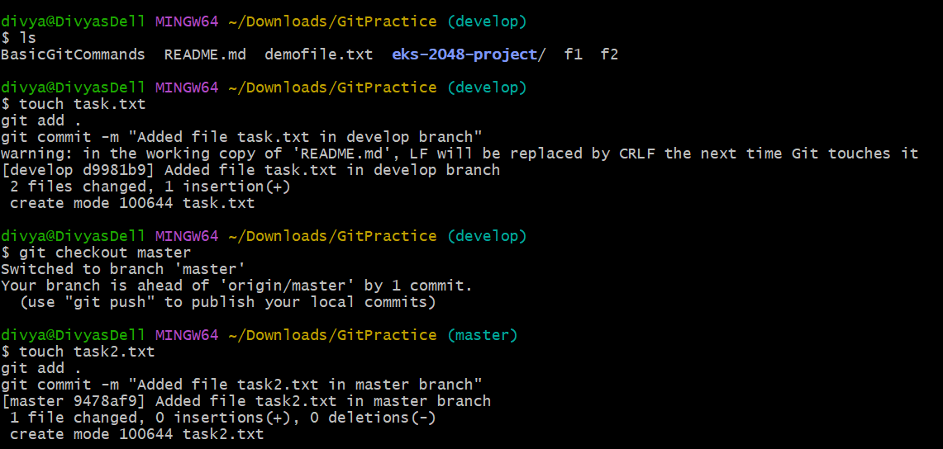
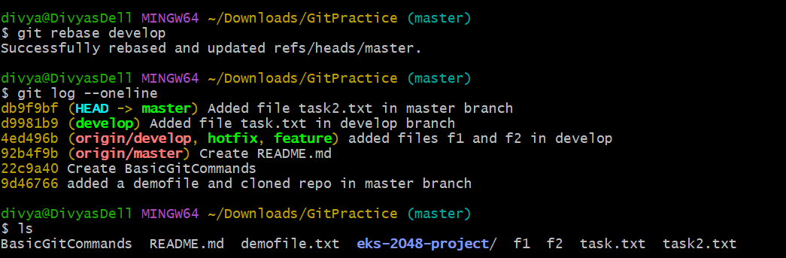
7. git branch -d <branch_name>: Deletes the specified branch (locally)
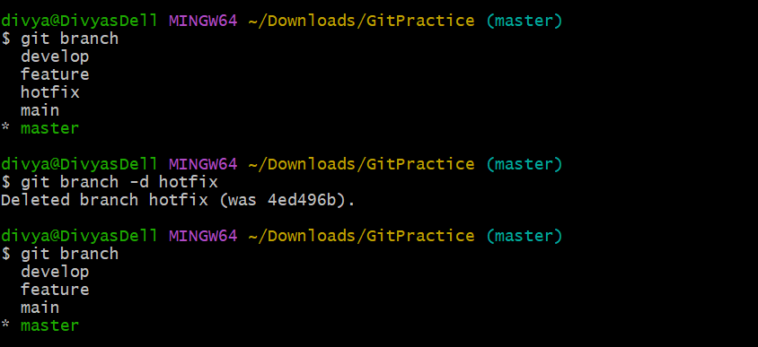
8. git branch -D <branch_name>: Forcefully deletes a branch(locally).
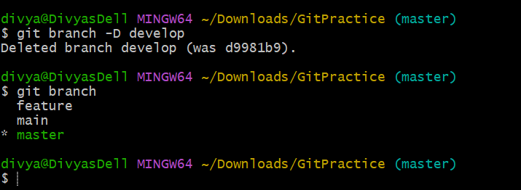
9. git remote set-head origin <branch_name>: Sets the default branch for the remote repository
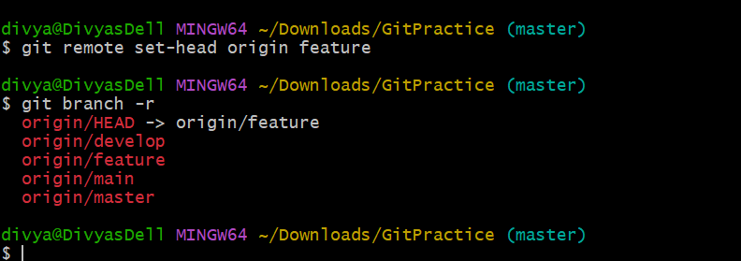
Remote Commands (Managing remotes and syncing with the cloud)
1. git remote -v: Shows the remote repository URLs.
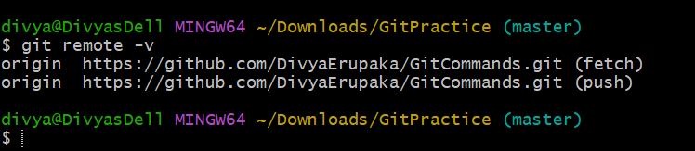
2. git remote add: Adds a new remote repository.
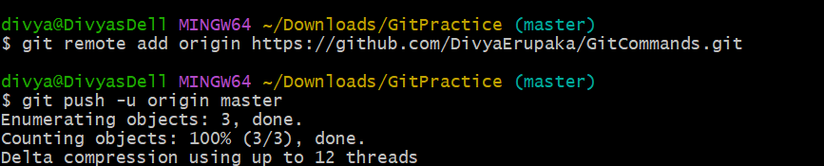
3. git remote remove: Removes a remote repository.
Overview: git remote remove removes a configured remote repository reference from a local Git repository.
Example: git remote remove origin
Objective: To remove an existing remote repository configuration from the local Git repository.
Prerequisites
- Git installed
- Local repository initialized
- Remote repository already configured
Steps Performed
Step 1: Navigate to Repository
cd ~/Downloads/GitPractice
Outcome
Moved into the local Git repository.
Step 2: Verify Existing Remote Repositories
git remote -v
Expected Output
origin https://github.com/DivyaErupaka/GitCommands.git (fetch)
origin https://github.com/DivyaErupaka/GitCommands.git (push)
Outcome
Confirmed that the remote repository origin exists.
Step 3: Remove Remote Repository
git remote remove origin
Outcome
Successfully removed the remote repository configuration named origin.
Step 4: Verify Remote Removal
git remote -v
Outcome
Confirmed that the remote repository was removed successfully.
Validation: Check Remote Names
git remote
Outcome: Verified that no remotes are configured.
4. git push origin <branch_name>: Pushes a branch to a remote repository.
Overview: git push origin <branch_name> is used to upload local branch commits to a remote repository.
Example:
git push origin master
Objective: To push local branch changes to the remote repository.
Prerequisites
- Git installed
- Local repository initialized or cloned
- Remote repository configured (origin)
- Changes committed locally
Steps Performed
Step 1: Navigate to Repository
cd ~/Downloads/GitPractice
Step 2: Check Current Branch
git branch
Expected Output
* master
Step 3: Create or Modify Files
Example:
touch sample.txt
Step 4: Add Files to Staging Area
git add .
Outcome
Added changes to the staging area.
Step 5: Commit Changes
git commit -m "Added sample file"
Expected Output
[master abc1234] Added sample file
1 file changed
create mode 100644 sample.txt
Step 6: Push Branch to Remote Repository
git push origin master
Expected Output
Enumerating objects: 5, done.
Counting objects: 100% (5/5), done.
Writing objects: 100% (3/3), done.
To https://github.com/DivyaErupaka/GitCommands.git
92b4f9b..db9f9bf master -> master
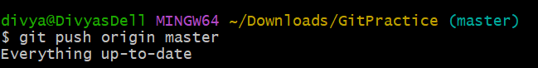
Validation: Verify Push Status
git status
Expected Result
On branch master
nothing to commit, working tree clean
5. git push -u origin <branch_name>: Pushes a branch to a remote repository and sets the upstream for the branch.
Overview: git push -u origin <branch_name> is used to:
- push a local branch to the remote repository
- establish an upstream tracking relationship between local and remote branches
After setting upstream, future push and pull operations can be performed using only:
git push
git pull
Example:
git push -u origin develop
Objective: To push a local branch to the remote repository and configure upstream tracking for easier future Git operations.
Prerequisites
- Git installed
- Local repository initialized or cloned
- Remote repository configured (origin)
- Local branch created
- Changes committed locally
Steps Performed
Step 1: Navigate to Repository
cd ~/Downloads/GitPractice
Outcome
Moved into the local Git repository.
Step 2: Create New Branch
git checkout -b develop
Expected Output
Switched to a new branch 'develop'
Step 3: Create or Modify Files
Example:
touch f1
Step 4: Add Changes to Staging Area
git add .
Step 5: Commit Changes
git commit -m "Added f1 file in develop branch"
Step 6: Push Branch and Set Upstream
git push -u origin develop
Expected Output
Enumerating objects: 5, done.
Counting objects: 100% (5/5), done.
Writing objects: 100% (3/3), done.
To https://github.com/DivyaErupaka/GitCommands.git
* [new branch] develop -> develop
branch 'develop' set up to track 'origin/develop'.
Outcome
- Branch pushed successfully to remote repository
- Upstream tracking relationship established

Validation
Validation 1: Verify Branch Tracking
git branch -vv
Expected Output
* develop abc1234 [origin/develop] Added f1 file in develop branch
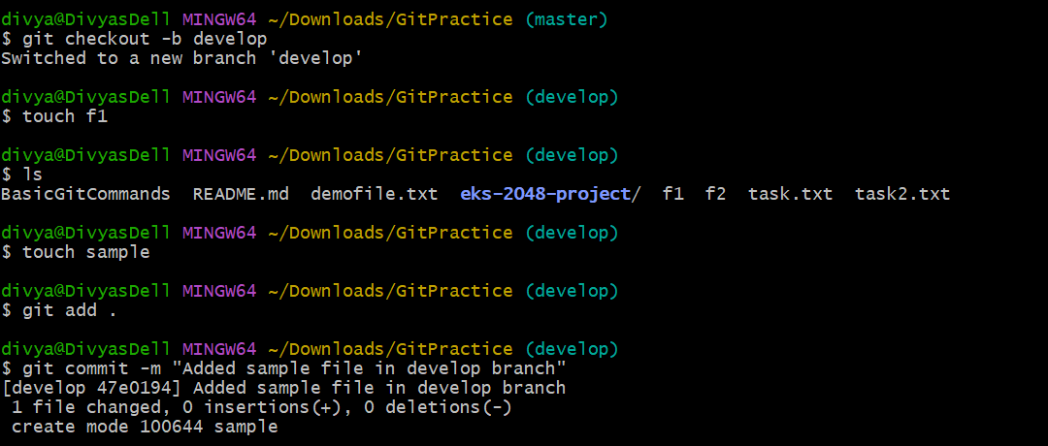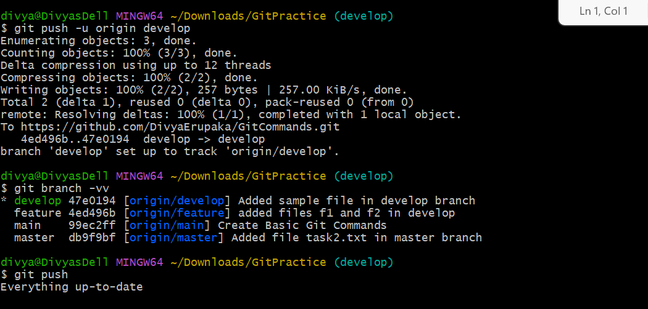

6. git pull origin <branch_name>: Fetches and merges a branch from the remote repository.
Overview: git pull origin <branch_name> is used to:
- fetch the latest changes from the remote repository
- automatically merge those changes into the current local branch
It combines the functionality of:
git fetch
git merge
Syntax:
git pull origin <branch_name>
Example:
git pull origin master
This fetches and merges the master branch from the remote repository into the current local branch.
Objective: To retrieve and integrate the latest changes from a remote repository into the local repository.
Prerequisites
- Git installed
- Local repository cloned or initialized
- Remote repository configured (origin)
- Internet connection
- Remote branch available
Steps Performed
Step 1: Navigate to Repository
cd ~/Downloads/GitPractice
Outcome
Moved into the local Git repository.
Step 2: Check Current Branch
git branch
Expected Output
* master
Step 3: Verify Current Files: ls
Step 4: Pull Latest Changes from Remote Repository
git pull origin master
Expected Output
From https://github.com/DivyaErupaka/GitCommands
* branch master -> FETCH_HEAD
Updating 92b4f9b..db9f9bf
Fast-forward
README.md | 2 ++
1 file changed, 2 insertions(+)
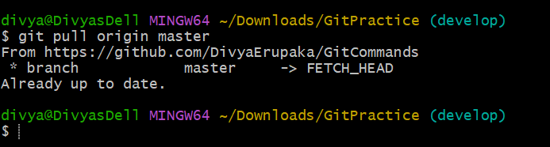
Validation : Verify Updated Files---- ls
7. git fetch origin: Downloads objects and refs from the remote repository.
Overview: git fetch origin downloads commits, branches, and references from the remote repository without merging them into the current local branch.
It updates remote-tracking branches such as:
origin/master
origin/main
Objective: To download the latest changes from the remote repository and update remote-tracking references without merging them into the local branch.
Prerequisites
- Git installed
- Local repository cloned or initialized
- Remote repository configured as origin
- Internet connection
Steps Performed
Step 1: Navigate to Repository
cd ~/Downloads/GitPractice
Outcome
Moved into the local Git repository.
Step 2: Verify Remote Repository
git remote -v
Expected Output
origin https://github.com/DivyaErupaka/GitCommands.git (fetch)
origin https://github.com/DivyaErupaka/GitCommands.git (push)
Outcome
Confirmed remote repository configuration.
Step 3: Fetch Latest Changes from Remote Repository
git fetch origin
Expected Output
remote: Enumerating objects: 4, done.
remote: Counting objects: 100% (4/4), done.
remote: Compressing objects: 100% (2/2), done.
remote: Total 3 (delta 1), reused 0 (delta 0), pack-reused 0
Unpacking objects: 100% (3/3), done.
From https://github.com/DivyaErupaka/GitCommands
22c9a40..92b4f9b master -> origin/master
Outcome
- Latest commits downloaded successfully
- Remote-tracking branch origin/master updated
- No local branch changes applied automatically
Step 4: Verify Downloaded Commits
git log HEAD..origin/master --oneline
Expected Output
92b4f9b Updated README file
Outcome
Confirmed that remote commits were fetched successfully and are available in origin/master.
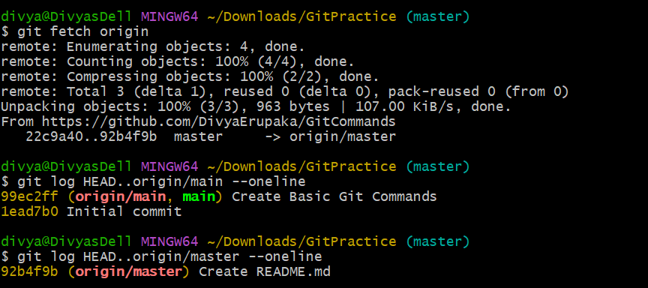
8. git remote show origin: Displays detailed information about a remote repository.
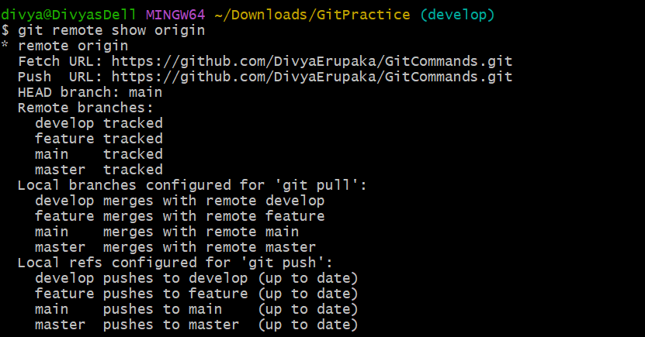
Staging and Committing (Managing changes)
1. git add . : Stages all modified files in the working directory.
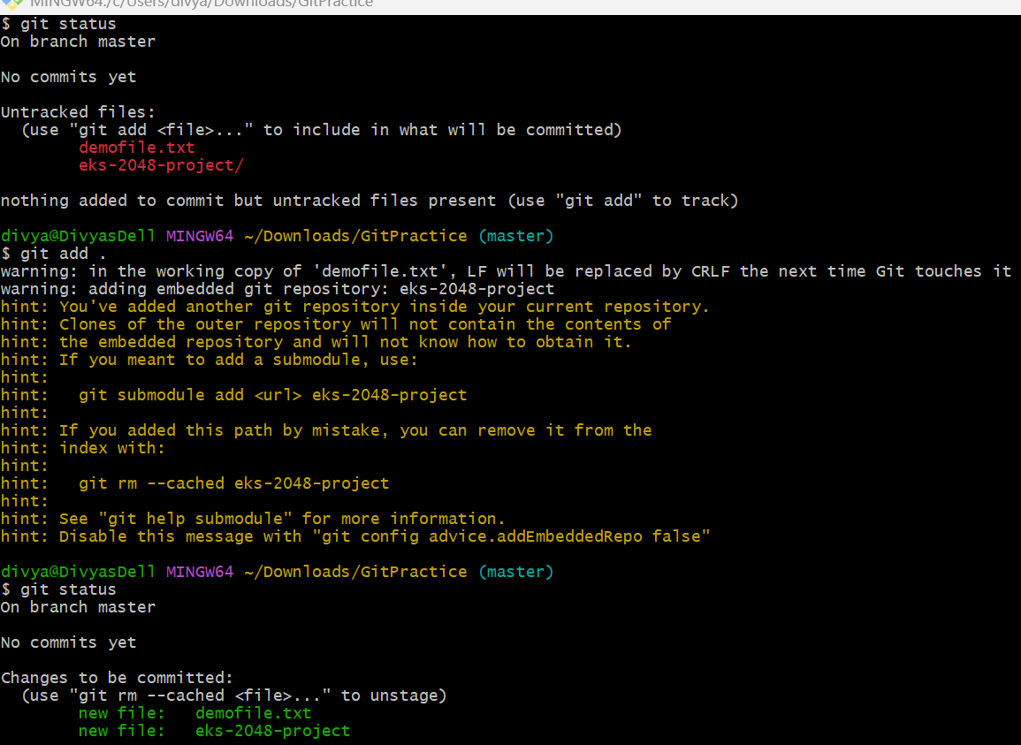
2. git add -A: Stages all modified files (including file deletions).
Overview: git add -A is used to stage all changes in the repository, including:
- new files
- modified files
- deleted files
It prepares all tracked and untracked changes for the next commit.
Syntax:
git add -A
Objective: To stage all repository changes, including file additions, modifications, and deletions, into the staging area.
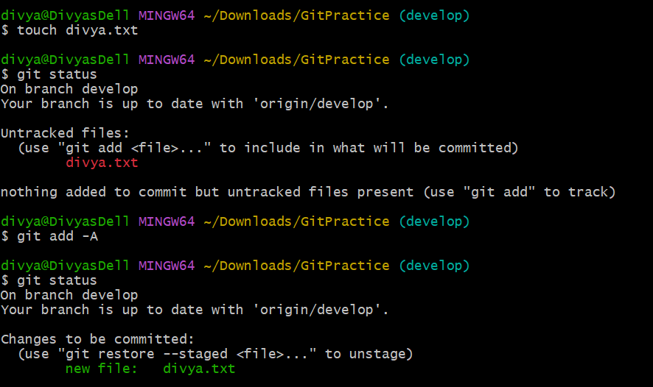
3. git reset: Unstages a file (reverts it to the working directory).
Overview: git reset un-stages files added to the staging area with git add.
It removes files from the staging area and moves them back to the working directory without deleting the actual file changes.
Example:
git reset README.md
This command unstages README.md while keeping the modifications in the working directory.
Objective: To unstage a staged file and move it back to the working directory.
Prerequisites
- Git installed
- Repository initialized or cloned
- File staged using git add
Steps Performed
Step 1: Navigate to Repository
cd ~/Downloads/GitPractice
Step 2: Modify an Existing File
echo "New content added" >> README.md
Outcome
Modified the README.md file.
Step 3: Stage the File
git add README.md
Outcome
Added the modified file to the staging area.
Step 4: Verify Staged File
git status
Expected Output
Changes to be committed:
modified: README.md
Outcome
Confirmed that README.md is staged.
Step 5: Unstage the File
git reset README.md
Expected Output
Unstaged changes after reset:
M README.md
Step 6: Verify File Status : git status
Expected Output
Changes not staged for commit:
modified: README.md
Validation : Verify File Content
cat README.md
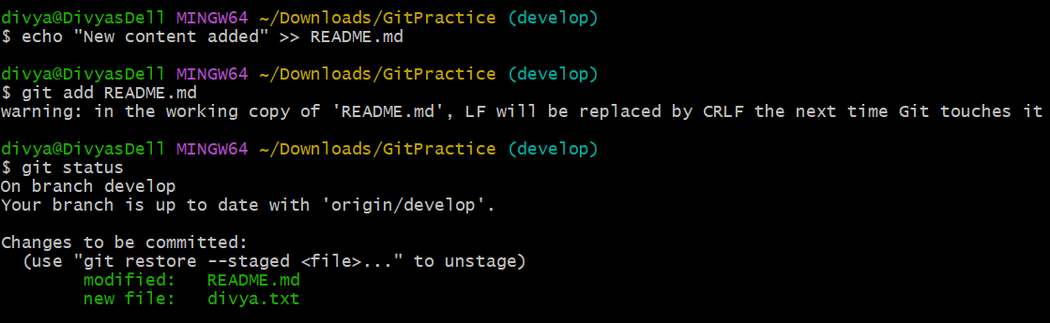
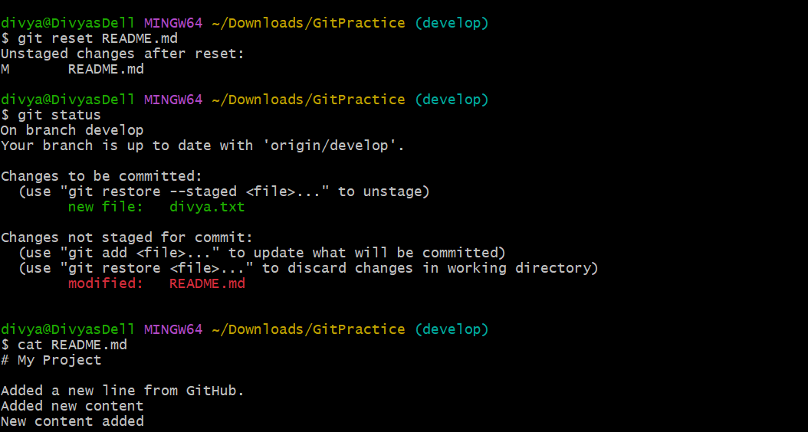
4. git commit --amend: Modifies the last commit (can change the commit message or add changes).
Overview: git commit --amend is used to modify the most recent commit.
It can be used to:
- change the last commit message
- add missed changes/files to the last commit
- update the previous commit without creating a new commit
Syntax:
git commit --amend
Objective: To modify the latest commit by updating the commit message or adding additional changes.
Prerequisites
- Git installed
- Repository initialized or cloned
- At least one existing commit available
Scenario 1: Change the Last Commit Message
Step 1: Navigate to Repository
cd ~/Downloads/GitPractice
Step 2: Create and Commit File
touch data.txt
git add .
git commit -m "Wrong commit message"
Step 3: Amend the Commit Message
git commit --amend -m "Added f1 file"
Expected Output
[master abc1234] Added f1 file
Date: Thu May 21
1 file changed
create mode 100644 f1
Outcome
Successfully updated the last commit message.
Step 4: Verify Commit History
git log --oneline
Expected Output
abc1234 Added f1 file
Outcome
Confirmed that the old commit message was replaced.
Scenario 2: Add Missed Changes to Last Commit
Step 1: Modify or Create Another File
touch f2
Outcome
Created another file after the previous commit.
Step 2: Stage the File
git add f2
Outcome
Added f2 to the staging area.
Step 3: Amend Previous Commit
git commit --amend
Expected Output
Git opens the editor with previous commit message.
Save and close the editor.
Outcome
- f2 added into previous commit
- No new commit created
- Existing commit updated
Validation
Validation 1: Check Commit History
git log --oneline
Expected Result
Only one updated commit should appear instead of two separate commits.
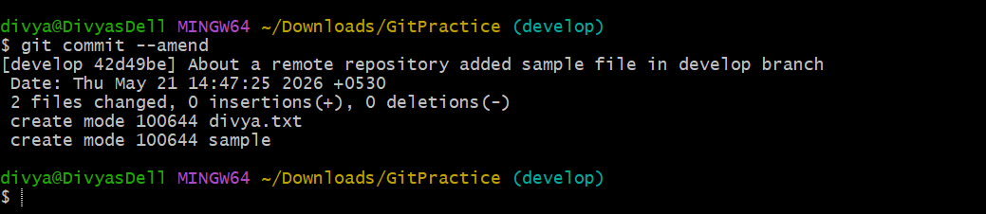
5. git commit --all: Automatically stages tracked files and commits them.
Overview: git commit --all is used to:
- automatically stage all modified and deleted tracked files
- create a commit in a single command
It eliminates the need to run git add separately for tracked files.
Syntax:
git commit --all -m "commit message"
OR
git commit -a -m "commit message"
Both commands are equivalent.
Objective: To automatically stage tracked file changes and commit them using a single command.
Prerequisites
- Git installed
- Repository initialized or cloned
- Existing tracked files available in repository
Important Note
git commit --all:
- stages modified tracked files
- stages deleted tracked files
- does NOT stage newly created untracked files
New files still require:
git add <file_name>
Steps Performed
Step 1: Navigate to Repository
cd ~/Downloads/GitPractice
Outcome
Moved into the local Git repository.
Step 2: Modify Existing Tracked File
echo "Updated README content" >> README.md
Outcome
Modified an existing tracked file.
Step 3: Check Repository Status
git status
Expected Output
Changes not staged for commit:
modified: README.md
Outcome
Confirmed unstaged modifications exist.
Step 4: Commit Using Git Commit --all
git commit --all -m "Updated README file"
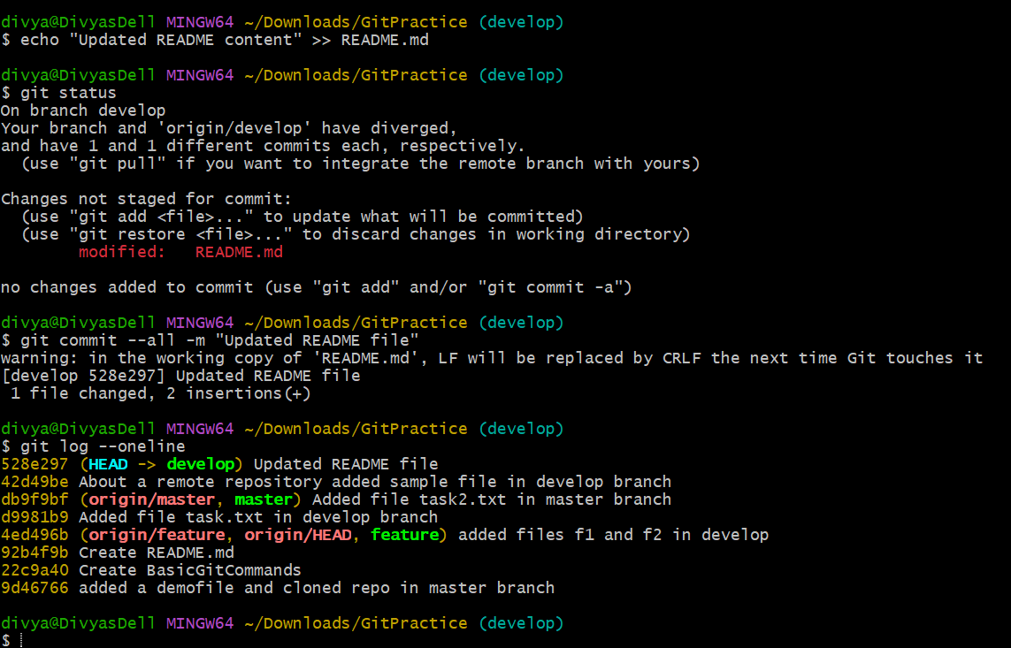
[master abc1234] Updated README file
1 file changed, 1 insertion(+)
Outcome
- Modified tracked file automatically staged
- Commit created successfully
- No separate git add command required
Validation
Validation 1: Check Commit History
git log --oneline
Expected Result
abc1234 Updated README file
Outcome
Confirmed commit was created successfully.
6. git commit -a: Stages and commits all modified files.
Overview: git commit -a is used to:
- automatically stage all modified and deleted tracked files
- create a commit in a single command
It is a shortcut that combines:
- staging tracked file changes
- committing changes
Example:
git commit -a -m "Updated README file"
Objective
To stage and commit all modified tracked files using a single command.
Prerequisites
- Git installed
- Repository initialized or cloned
- Existing tracked files available in repository
Important Note
git commit -a:
- stages modified tracked files
- stages deleted tracked files
- does NOT stage newly created untracked files
New files must still be added manually using:
git add <file_name>
Steps Performed
Step 1: Navigate to Repository
cd ~/Downloads/GitPractice
Outcome
Moved into the local Git repository.
Step 2: Modify an Existing File
echo "Updated content" >> README.md
Outcome
Modified the tracked file README.md.
Step 3: Check Repository Status
git status
Expected Output
Changes not staged for commit:
modified: README.md
Outcome
Confirmed unstaged modifications exist.
Step 4: Commit Using Git Commit -a
git commit -a -m "Updated README file"
Expected Output
[master abc1234] Updated README file
1 file changed, 1 insertion(+)
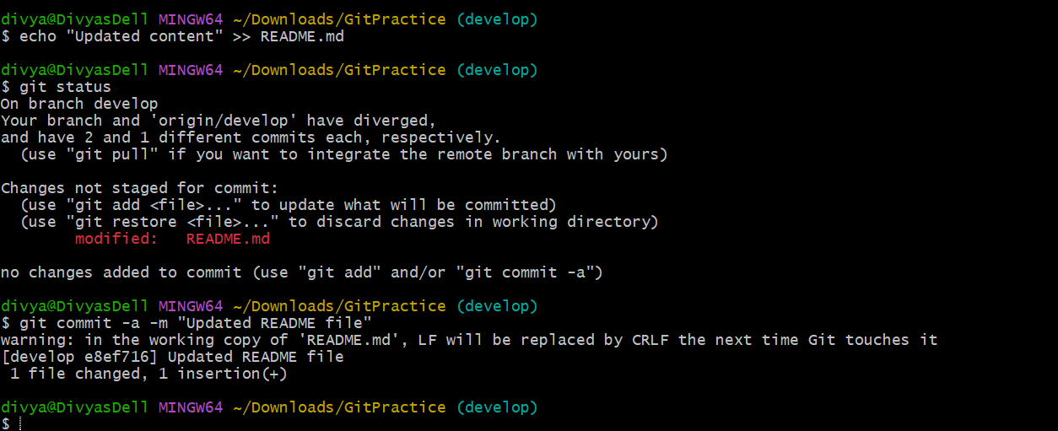
7. git commit --no-verify: Skips pre-commit hooks while committing.
Overview: git commit --no-verify is used to skip Git hooks (especially pre-commit and commit-msg hooks) during the commit process.
Normally, Git executes configured hooks before completing a commit. Using --no-verify bypasses these validations.
Example:
git commit --no-verify -m "Added README updates"
Objective
To create a commit while bypassing pre-commit validation hooks.
Prerequisites
- Git installed
- Repository initialized or cloned
- Git hooks configured (optional)
- Changes staged for commit
Common Use Cases
- Temporarily bypass failing hooks
- Skip linting or formatting checks
- Skip automated tests
- Emergency or quick commits
Important Note
Using --no-verify skips validation checks, so:
- code quality checks may not run
- tests may not execute
- commit message validation may be bypassed
Use carefully in shared projects.
Steps Performed
Step 1: Navigate to Repository
cd ~/Downloads/GitPractice
Outcome
Moved into the local Git repository.
Step 2: Modify or Create File
echo "Updated content" >> README.md
Outcome
Modified the README.md file.
Step 3: Stage Changes
git add README.md
Outcome
Added file changes to the staging area.
Step 4: Commit Without Running Hooks
git commit --no-verify -m "Updated README without verification"
Expected Output
[master abc1234] Updated README without verification
1 file changed, 1 insertion(+)
Outcome
- Commit created successfully
- Pre-commit hooks skipped
- No validation checks executed
Validation
Validation 1: Verify Commit History
git log –oneline
8. git reset --soft HEAD~1: Moves the HEAD pointer back one commit but leaves your changes staged.
Overview: git reset --soft HEAD~1 moves the current branch pointer (HEAD) back by one commit while keeping all changes staged in the staging area. It removes the latest commit from Git history without losing the file changes.
Syntax:
git reset --soft HEAD~1
Objective
To undo the most recent commit while preserving all committed changes in the staging area.
Prerequisites
- Git installed
- Repository initialized or cloned
- At least one existing commit available
Important Concept
After running:
git reset --soft HEAD~1
Git:
- removes the latest commit
- keeps file changes intact
- keeps changes staged (git add state preserved)
Steps Performed
Step 1: Navigate to Repository
cd ~/Downloads/GitPractice
Outcome
Moved into the local Git repository.
Step 2: Create a File
touch f1
Outcome
Created a new file named f1.
Step 3: Stage the File
git add f1
Outcome
Added file to staging area.
Step 4: Commit the File
git commit -m "Added f1 file"
Expected Output
[master abc1234] Added f1 file
Outcome
Created a new commit.
Step 5: Verify Commit History
git log --oneline
Expected Output
abc1234 Added f1 file
Outcome
Confirmed the latest commit exists.
Step 6: Undo Last Commit Using Soft Reset
git reset --soft HEAD~1
Outcome
- Last commit removed from history
- File changes preserved
- Changes remain staged
Step 7: Verify Repository Status
git status
Expected Output
Changes to be committed:
new file: f1
Outcome
Confirmed:
- commit removed
- changes still staged
Validation 1: Verify Commit Removal
git log --oneline
Expected Result
The previous commit should no longer appear.
Validation 2: Verify Staged Changes
git diff --cached
Outcome
Displayed staged file changes still available.
Validation 3: Verify File Exists
ls
Expected Result
f1
Outcome
Confirmed file still exists locally.
Difference Between Reset Types
Command | Commit Removed | Changes Preserved | Changes Staged
git reset --soft HEAD~1 | Yes | Yes | Yes
git reset --mixed HEAD~1 | Yes | Yes | No
git reset --hard HEAD~1 | Yes | No | No
9. git reset --hard HEAD~1: Moves the HEAD pointer back one commit and discards changes in the working directory.
Overview
git reset --hard HEAD~1 is used to:
- move the HEAD pointer back by one commit
- permanently discard changes from:
  - commit history
  - staging area
  - working directory
This command completely removes the latest commit and its associated changes.
Syntax:
git reset --hard HEAD~1
Objective
To remove the most recent commit and permanently delete all related file changes.
Warning
git reset --hard permanently deletes changes.
Discarded changes cannot be recovered easily unless they exist in:
- remote repository
- stash
- reflog
Use carefully.
Prerequisites
- Git installed
- Repository initialized or cloned
- At least one existing commit available
Steps Performed
Step 1: Navigate to Repository
cd ~/Downloads/GitPractice
Outcome
Moved into the local Git repository.
Step 2: Create a File
touch f1
Outcome
Created a new file named f1.
Step 3: Stage the File
git add f1
Outcome
Added file to staging area.
Step 4: Commit the File
git commit -m "Added f1 file"
Expected Output
[master abc1234] Added f1 file
Outcome
Created a new commit.
Step 5: Verify Commit History
git log --oneline
Expected Output
abc1234 Added f1 file
Outcome
Confirmed latest commit exists.
Step 6: Reset Hard to Previous Commit
git reset --hard HEAD~1
Expected Output
HEAD is now at db9f9bf Updated README
Outcome
- latest commit removed
- file changes deleted
- working directory cleaned
Validation
Validation 1: Verify Commit Removal
git log --oneline
Expected Result
Removed commit should no longer appear.
Outcome
Confirmed latest commit was deleted.
Viewing and Comparing Changes (Inspecting changes)
1. Git diff - Shows changes between your working directory and the index (unstaged changes).
Overview: git diff is used to display the differences between:
- the working directory
- the staging area (index)
It shows unstaged changes that were modified but not yet added using git add.
Syntax:
git diff
Objective: To inspect unstaged modifications in files before staging or committing them.
Prerequisites
- Git installed
- Repository initialized or cloned
- Existing tracked files available
Current repository files:
BasicGitCommands README.md app.py demofile.txt dev.txt divya.txt eks-2048-project/ f1 f2 sample task.txt task2.txt
Steps Performed
Step 1: Navigate to Repository
cd ~/Downloads/GitPractice
Outcome
Moved into the local Git repository.
Step 2: Modify Existing File
Example using divya.txt:
echo "Git diff example content" >> divya.txt
Outcome
Modified the divya.txt file.
Step 3: Check Repository Status
git status
Expected Output
Changes not staged for commit:
modified: divya.txt
Outcome
Confirmed unstaged modifications exist.
Step 4: View Unstaged Changes
git diff
Expected Output
diff --git a/divya.txt b/divya.txt
index e69de29..abcd123 100644
--- a/divya.txt
+++ b/divya.txt
@@ -1 +1,2 @@
Existing content
+Git diff example content
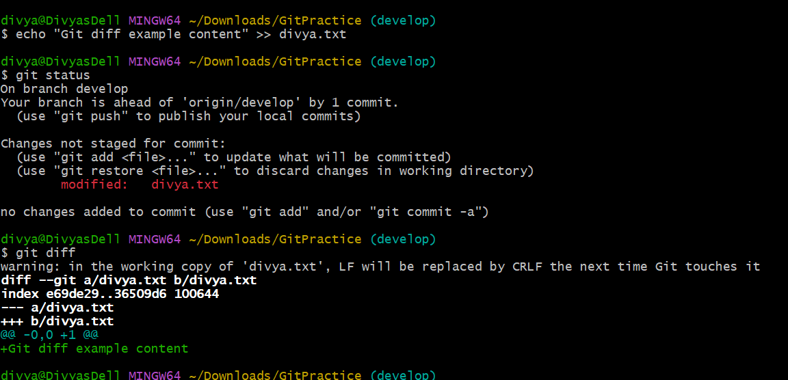
2. git diff --staged: Shows changes between the index (staged files) and the last commit.
Overview: git diff --staged is used to display the differences between
- the staging area (index)
- the last commit
It shows changes that have been staged using git add but are not yet committed.
Syntax:
git diff --staged
Objective: To inspect staged changes before committing them to the repositor
Prerequisites
- Git installed
- Repository initialized or cloned
- Files staged using git add
Current repository files:
BasicGitCommands README.md app.py demofile.txt dev.txt divya.txt eks-2048-project/ f1 f2 sample task.txt task2.txt
Steps Performed
Step 1: Navigate to Repository
cd ~/Downloads/GitPractice
Outcome
Moved into the local Git repository.
Step 2: Modify Existing File
Example using task.txt:
echo "Git staged diff example" >> task.txt
Outcome
Modified the task.txt file.

Step 3: Check Repository Status
git status
Expected Output
Changes not staged for commit:
modified: task.txt
Outcome
Confirmed unstaged modifications exist.
Step 4: Stage the File
git add task.txt
Outcome
Added task.txt changes to the staging area.
Step 5: Verify Staged File
git status
Expected Output
Changes to be committed:
modified: task.txt
Outcome
Confirmed file is staged.
Step 6: View Staged Changes
git diff --staged
Expected Output
diff --git a/task.txt b/task.txt
index e69de29..abcd123 100644
--- a/task.txt
+++ b/task.txt
@@ -1 +1,2 @@
Existing content
+Git staged diff example
Outcome
Displayed differences between:
- staging area
- last committed version
Understanding Git Diff Symbols
Symbol | Meaning
--- | Original file
+++ | Modified file
- | Removed line
+ | Added line

Validation : Commit the Staged Changes
git commit -m "Updated task.txt"
Outcome
Committed staged changes successfully.
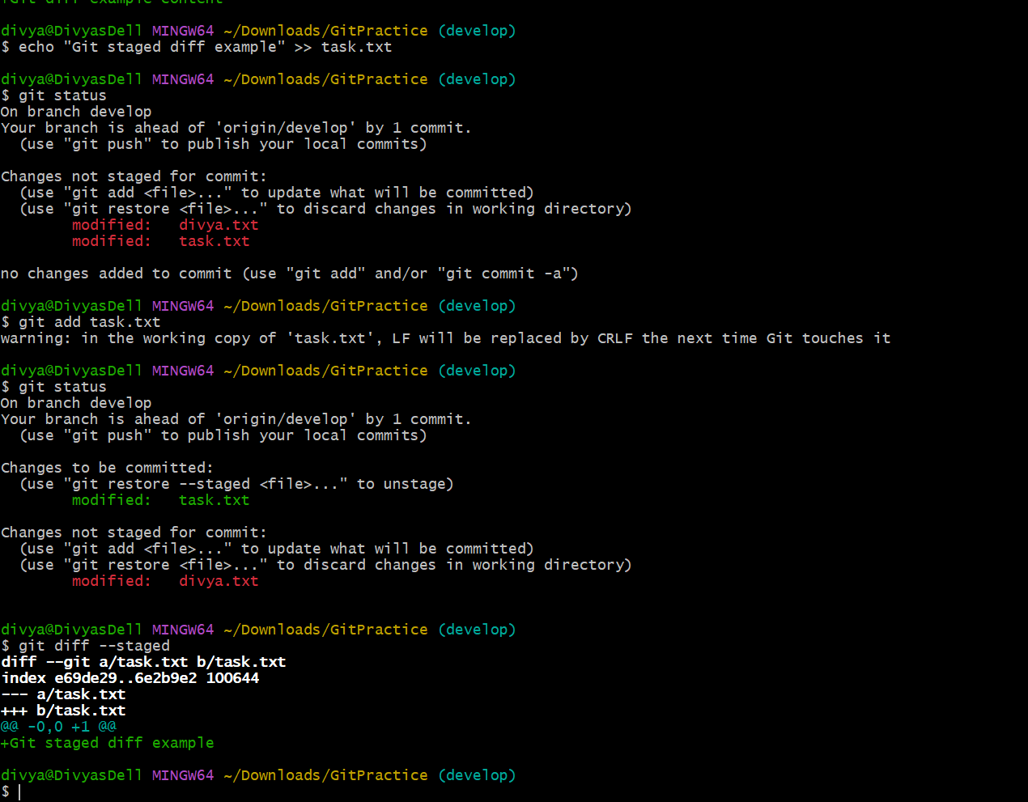
3. git diff <commit_id>: Shows the differences between your working directory and a specific commit.
Git Diff <commit_id> Documentation
Overview: git diff <commit_id> is used to compare:
- the current working directory
- a specific commit
It shows all differences between the selected commit and the current uncommitted state of the repository.
Syntax:
git diff <commit_id>
Example:
git diff f55806e
Objective: To inspect changes between the current working directory and a previous commit.
Prerequisites
- Git installed
- Repository initialized or cloned
- Existing commits available in repository
Current repository files:
BasicGitCommands README.md app.py demofile.txt dev.txt divya.txt eks-2048-project/ f1 f2 sample task.txt task2.txt
Steps Performed
Step 1: Navigate to Repository
cd ~/Downloads/GitPractice
Outcome
Moved into the local Git repository.
Step 2: View Commit History
git log --oneline
Example Output
f55806e Added app.py
db9f9bf Updated README
92b4f9b Initial commit
Outcome
Displayed available commit IDs.
Step 3: Modify Existing File
Example using dev.txt:
echo "New diff comparison content" >> dev.txt
Outcome
Modified dev.txt in working directory.
Step 4: Check Repository Status
git status
Expected Output
Changes not staged for commit:
modified: dev.txt
Outcome
Confirmed unstaged modifications exist.
Step 5: Compare with Specific Commit
git diff f55806e
Outcome
Displayed differences between:
- selected commit (f55806e)
- current working directory
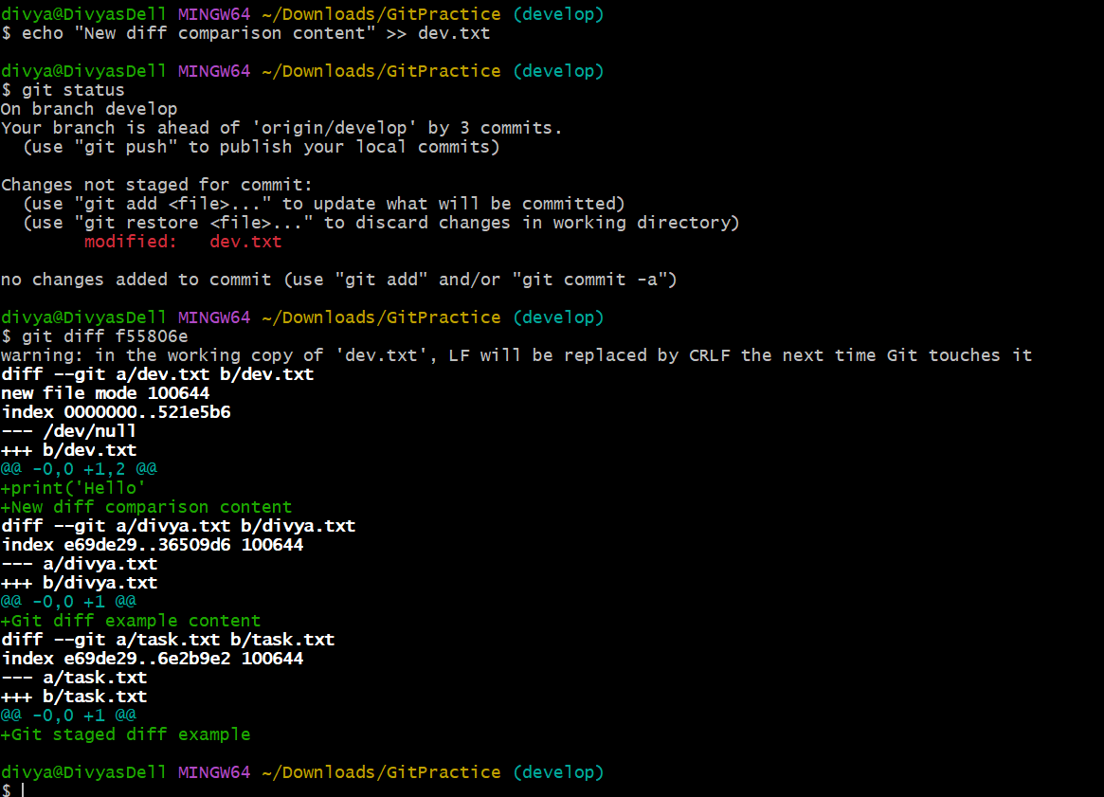
4. git log: Displays the commit history.
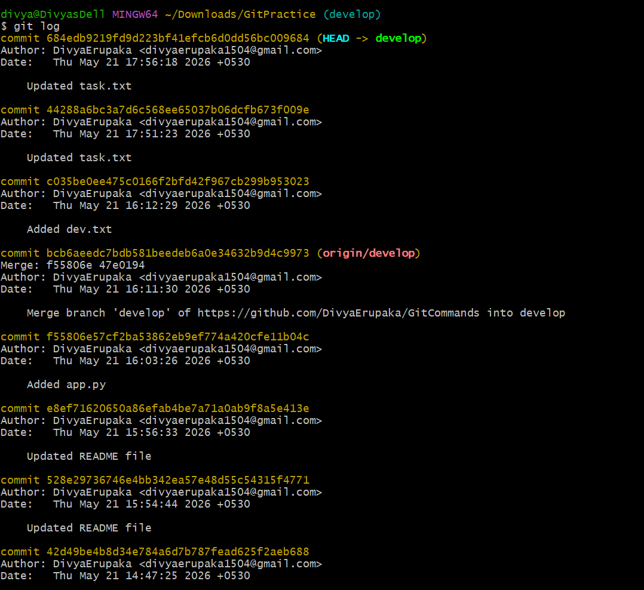
5. git log --oneline: Displays the commit history in a simplified one-line format.
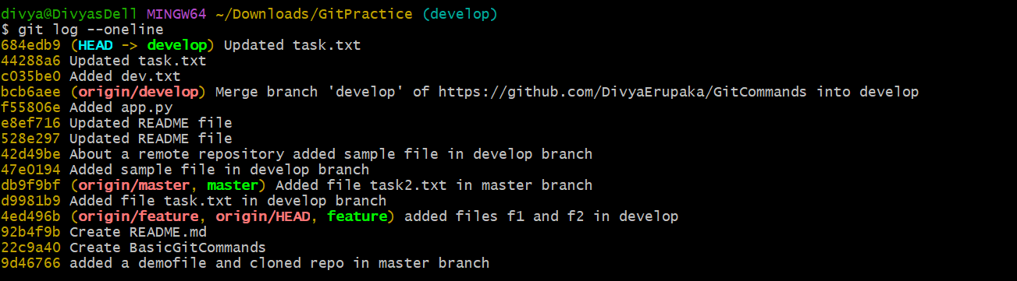
6. git log --graph: Displays the commit history as a graph.
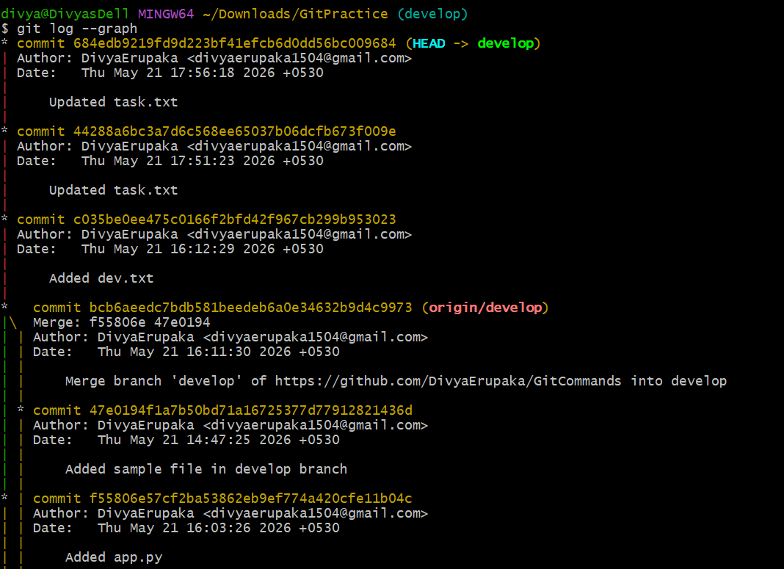
7. git log --author="name": Filters commits by a specific author.
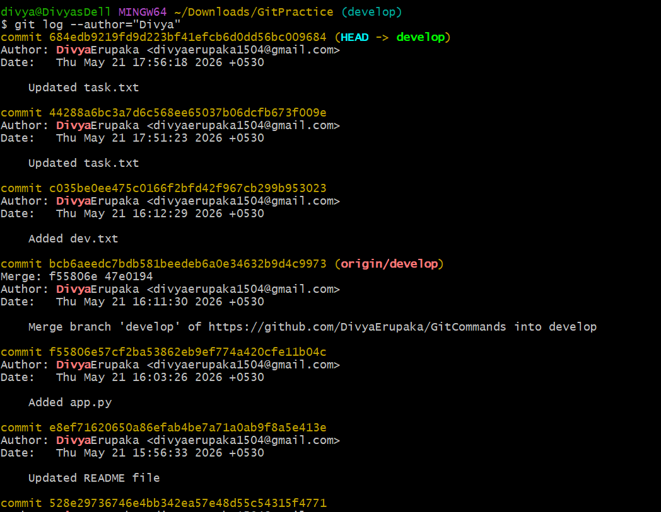
8. git log --since="2 weeks ago": Filtrs commits made after a specific date.
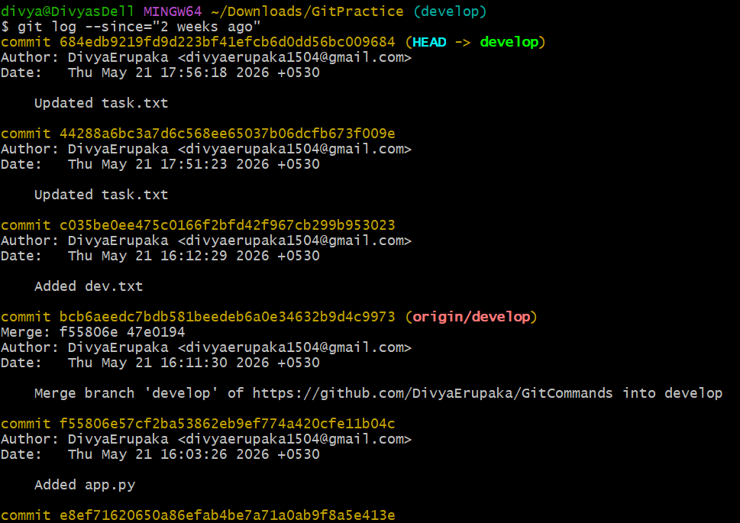

9. git blame : Shows line-by-line annotations for a file, telling who last modified each line.
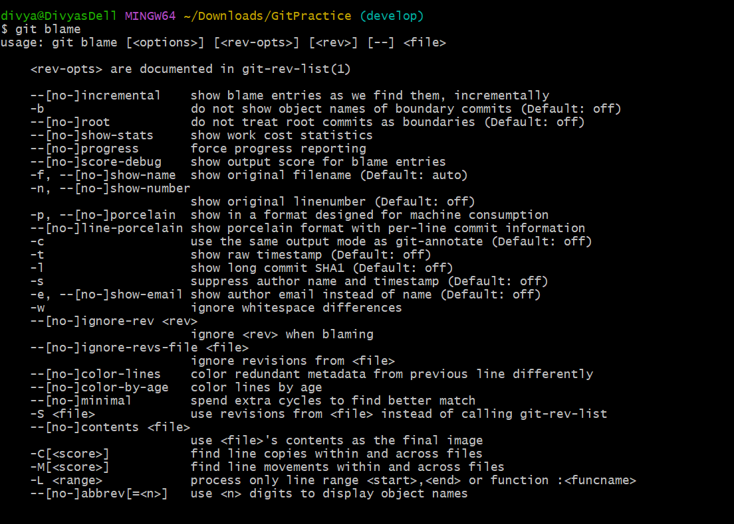
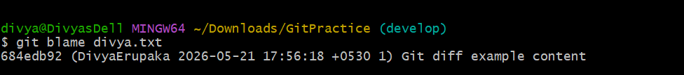
10. git show <commit_id>: Shows details of a specific commit (including diff and metadata).
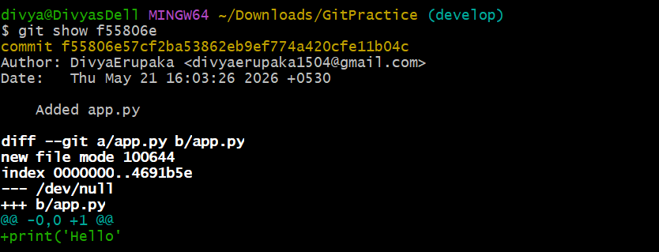
11. git show <commit_id>:<file_path> is used to display the contents of a specific file from a particular commit.
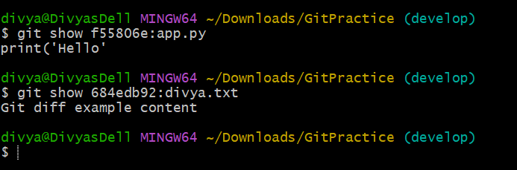
Reverting and Resetting (Undoing changes)
1. git revert <commit_id>: Creates a new commit that undoes the changes of the specified commit.
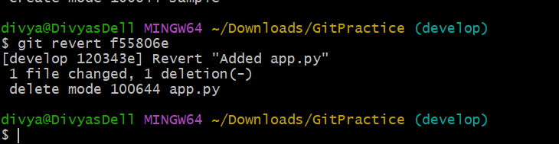
2. git restore : Restores the file(s) in the working directory from the index or a commit.
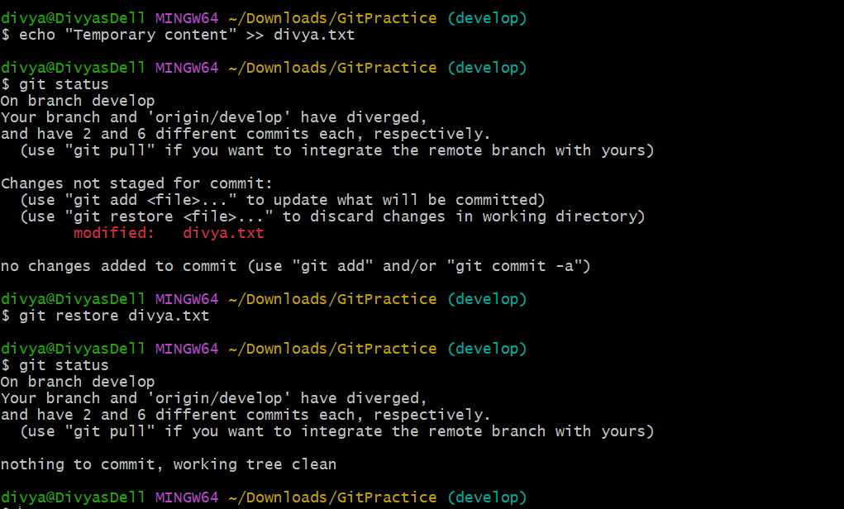
3. git restore --staged : Removes a file from the staging area.
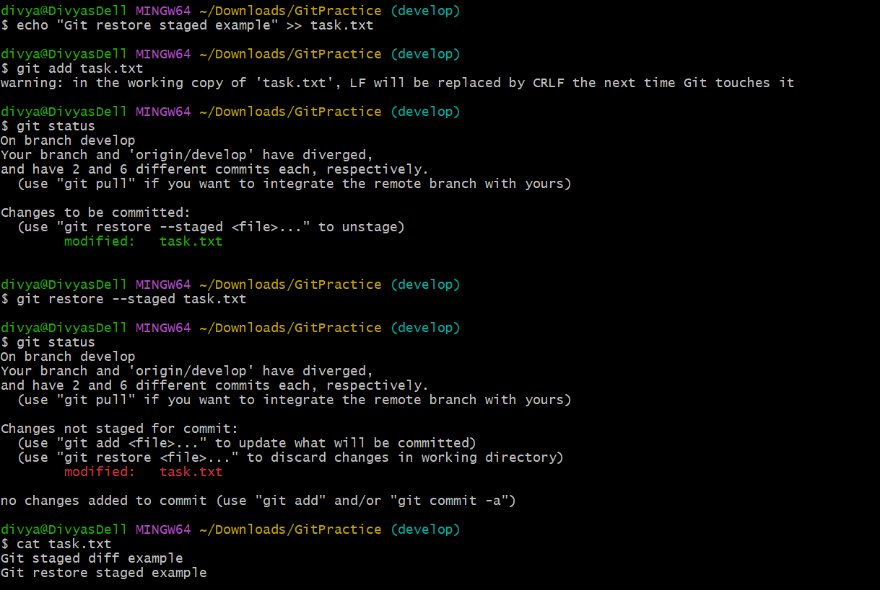
4. git clean -f: Removes untracked files in the working directory.
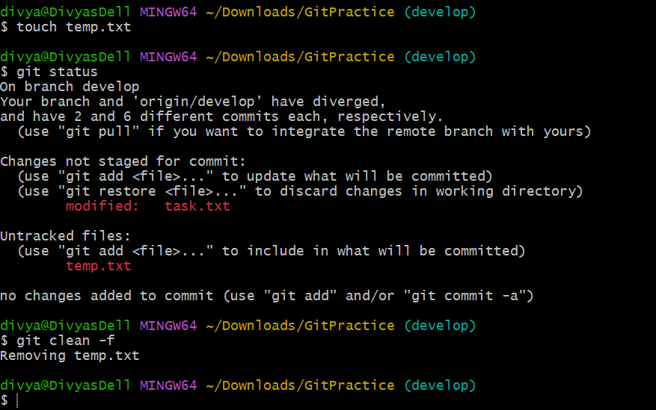
5. git clean -fd: Removes untracked files and directories.
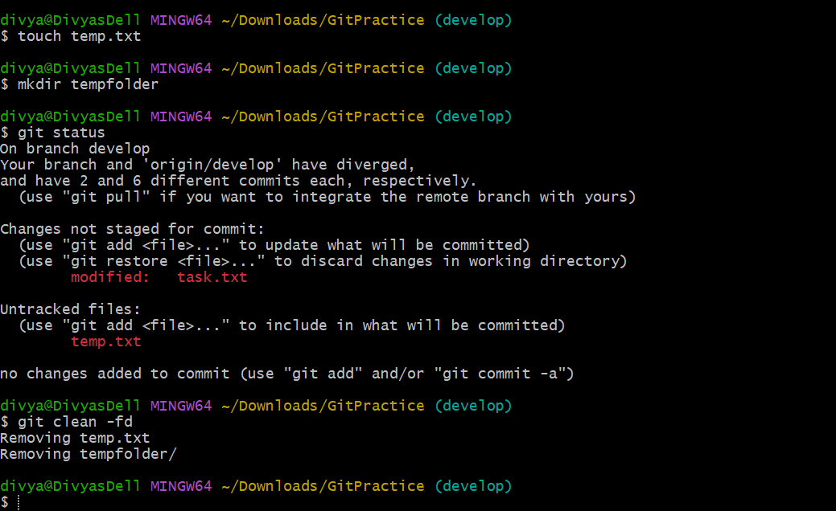
Stashing (Temporarily saving changes)
1. git stash: Stashes the changes in your working directory (both staged and unstaged).
Overview: git stash is used to temporarily save changes in the working directory without committing them.
It stashes:
- staged changes
- unstaged changes
and restores the working directory to a clean state.
This is useful when you want to:
- switch branches
- pull latest changes
- work on another task temporarily
without losing current work.
Syntax:
git stash
Objective: To temporarily store working directory changes and clean the repository state.
Prerequisites
- Git installed
- Repository initialized or cloned
- Modified or staged files available
Current repository files:
BasicGitCommands README.md app.py demofile.txt dev.txt divya.txt eks-2048-project/ f1 f2 sample task.txt task2.txt
Steps Performed
Step 1: Navigate to Repository
cd ~/Downloads/GitPractice
Outcome
Moved into the local Git repository.
Step 2: Modify Existing Files
Example:
echo "Temporary change" >> divya.txt
echo "Another change" >> task.txt
Outcome
Modified:
- divya.txt
- task.txt
Step 3: Verify Changes
git status
Expected Output
Changes not staged for commit:
modified: divya.txt
modified: task.txt
Outcome
Confirmed working directory contains changes.
Step 4: Stash Changes
git stash
Expected Output
Saved working directory and index state WIP on develop
Outcome
Stored:
- staged changes
- unstaged changes
in stash area.
Working directory became clean.
Validation: Verify Clean Working Directory
git status
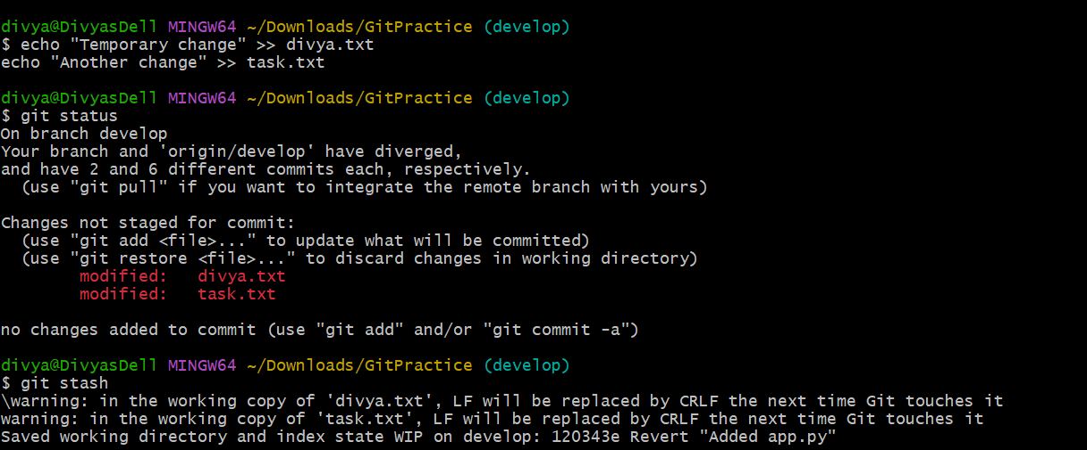
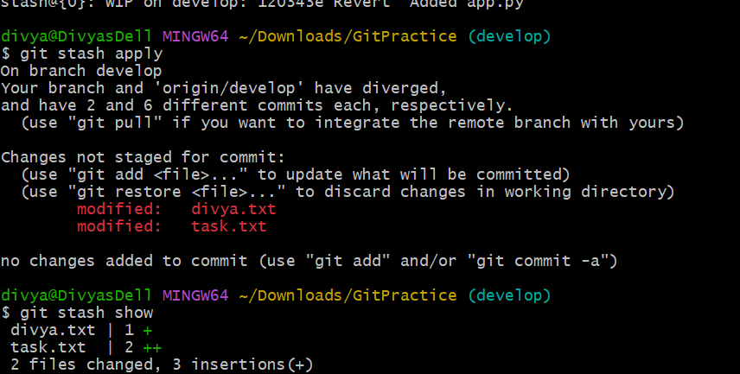
2. git stash list: Lists all the stashes.
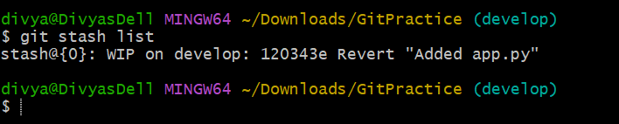
3. git stash pop: Applies the latest stash and removes it from the stash list.
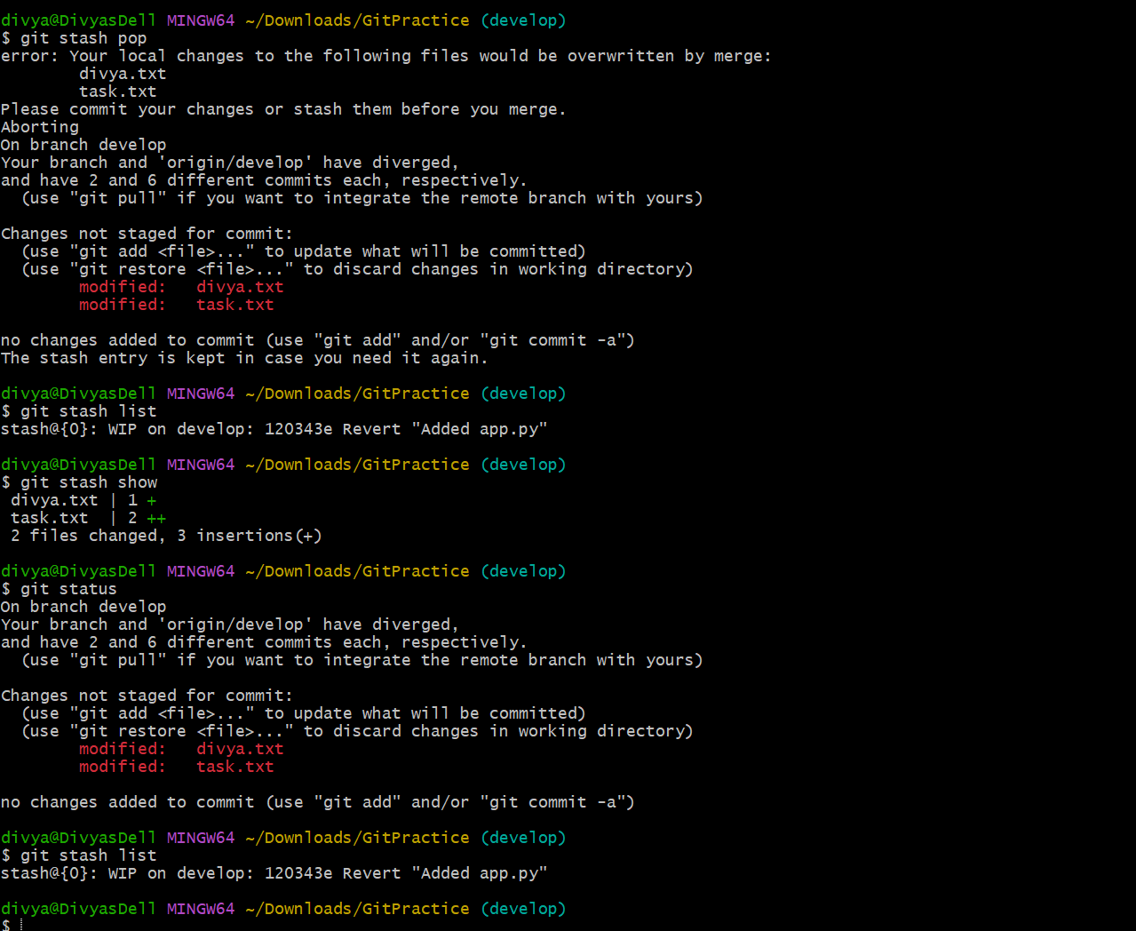
4. git stash apply: Applies a stash without removing it from the list.
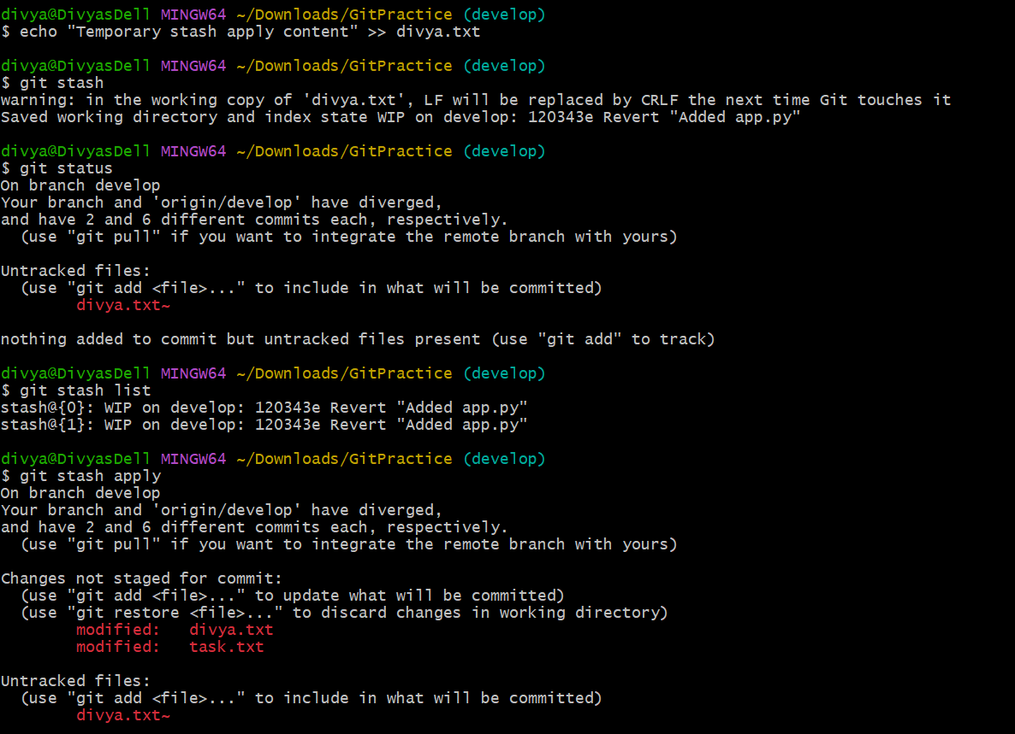
5. git stash drop: Removes a specific stash from the stash list.
Overview
git stash drop is used to delete a specific stash entry from the stash list.
It removes stored stashed changes permanently.
Syntax:
git stash drop <stash_id>
Example:
git stash drop stash@{0}
Objective: To remove an unwanted stash entry from the repository stash list.
Prerequisites
- Git installed
- Repository initialized or cloned
- At least one stash available
Steps Performed
Step 1: Navigate to Repository
cd ~/Downloads/GitPractice
Outcome
Moved into the local Git repository.
Step 2: Create Changes
Example:
echo "Temporary stash content" >> divya.txt
Outcome
Modified divya.txt.
Step 3: Create Stash
git stash
Expected Output
Saved working directory and index state WIP on develop
Outcome
Stored changes in stash area.
Step 4: Verify Stash List
git stash list
Example Output
stash@{0}: WIP on develop
Outcome
Confirmed stash entry exists.
Step 5: Remove Specific Stash
git stash drop stash@{0}
Expected Output
Dropped stash@{0}
Outcome
Deleted selected stash entry permanently.
Validation : Verify Stash Removal
git stash list
Expected Result
<empty>
Outcome
Confirmed stash entry was removed.
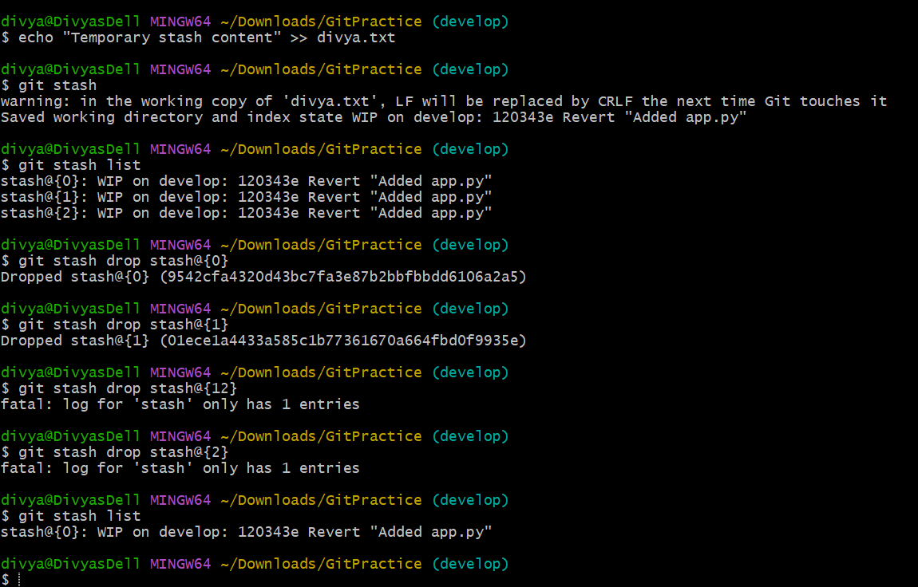
6. git stash clear: Clears all stashes.
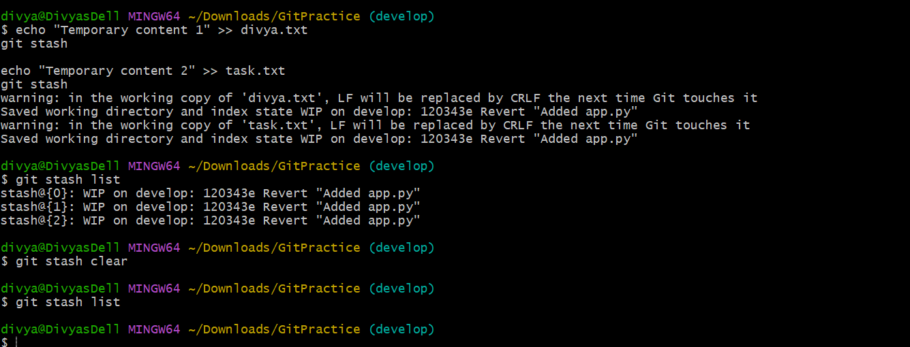
Tags (Managing versions)
Overview
Git tags are used to mark important points in repository history such as:
- releases
- versions
- milestones
Tags are static references to commits.
Common examples:
- v1.0
- v2.1
- release-final
1. git tag
Purpose: Lists all tags in the repository.
Syntax
git tag
Example
git tag
Expected Output
v1.0
v2.0
release-final
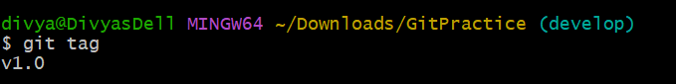
2. git tag <tag_name>
Purpose
Creates a lightweight tag at the current commit.
Syntax
git tag <tag_name>
Example
git tag v1.0
Validation
git tag
Expected Output
v1.0
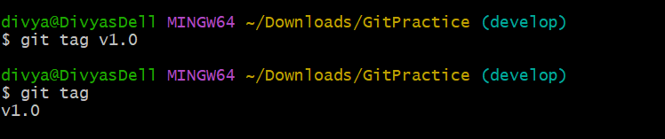
Outcome
Created lightweight tag successfully.
3. git tag -a <tag_name> -m "message"
Purpose
Creates an annotated tag with:
- tagger name
- date
- message

Syntax
git tag -a <tag_name> -m "message"

Example
git tag -a v2.0 -m "Version 2 release"

Validation
git show v2.0
Expected Output
tag v2.0
Tagger: Divya
Version 2 release
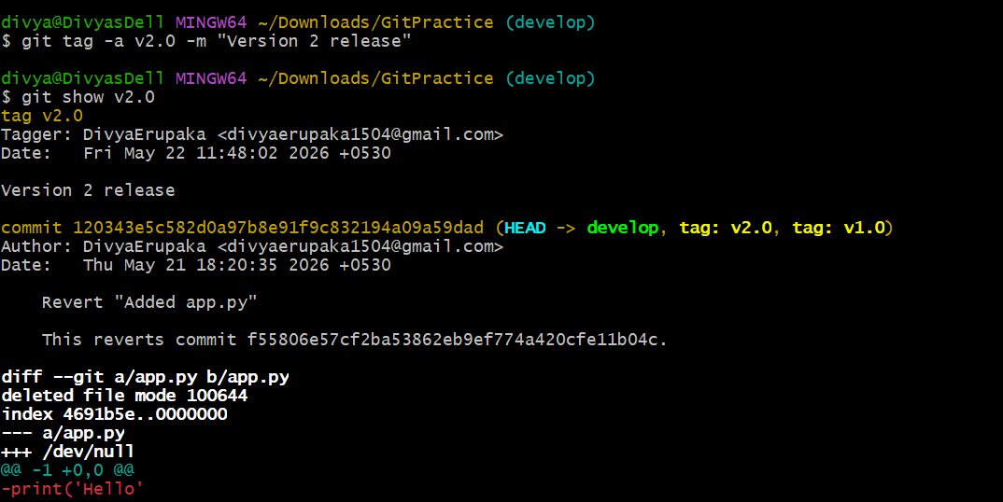
4. git tag -d <tag_name>
Purpose
Deletes a local tag.
Syntax
git tag -d <tag_name>
Example
git tag -d v1.0
Expected Output
Deleted tag 'v1.0'
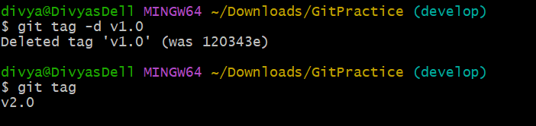
Validation
git tag
Outcome
Confirmed tag removed locally.
5. git push origin <tag_name>
Purpose
Pushes a specific tag to remote repository.
Syntax
git push origin <tag_name>
Example
git push origin v2.0
Expected Output
* [new tag] v2.0 -> v2.0
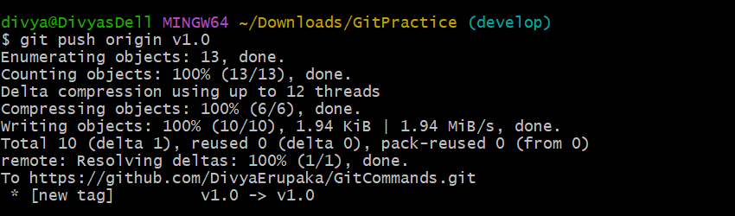
Outcome
Pushed selected tag to remote repository.
6. git push origin --tags
Purpose
Pushes all local tags to remote repository.
Syntax
git push origin --tags
Example
git push origin --tags
Expected Output
* [new tag] v1.0 -> v1.0
* [new tag] v2.0 -> v2.0
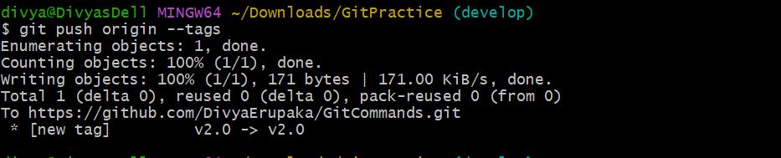
Outcome
Pushed all local tags to remote repository.
7. git fetch --tags
Purpose
Fetches all tags from remote repository.
Syntax
git fetch --tags
Example
git fetch --tags
Expected Output
[new tag] v1.0 -> v1.0
Outcome
Downloaded all remote tags into local repository.
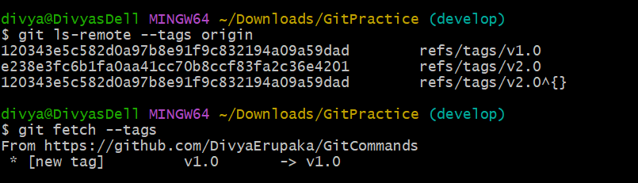
Validation Steps
View Tags
git tag
Git Config and Info (Configuration and repository
information)
1. git config --global user.name "Your Name"
Sets global username for Git commits
Step 1: Set Username
git config --global user.name "Divya"
Outcome
Configured global Git username.
Step 2: Verify Username
git config --global user.name
Expected Output
Divya
Outcome
Confirmed username successfully configured.
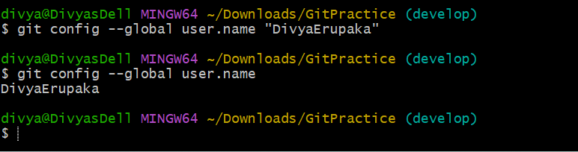
2. git config --global user.email "youremail@example.com"
Sets global email for Git commits
Step 1: Set Email
git config --global user.email "divya@example.com"
Outcome
Configured global Git email.
Step 2: Verify Email
git config --global user.email
Expected Output
divya@example.com
Outcome
Confirmed email successfully configured.
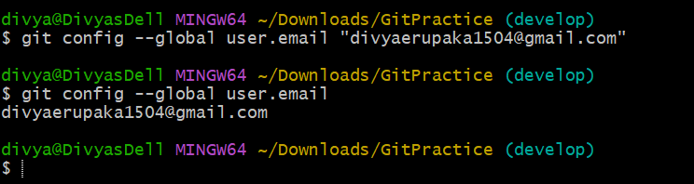
3. git config --list
Lists all Git configuration settings
Step 1: View Configurations
git config --list
Expected Output
user.name=Divya
user.email=divya@example.com
core.editor=code --wait
color.ui=true
alias.st=status
Outcome
Displayed all Git configuration settings.
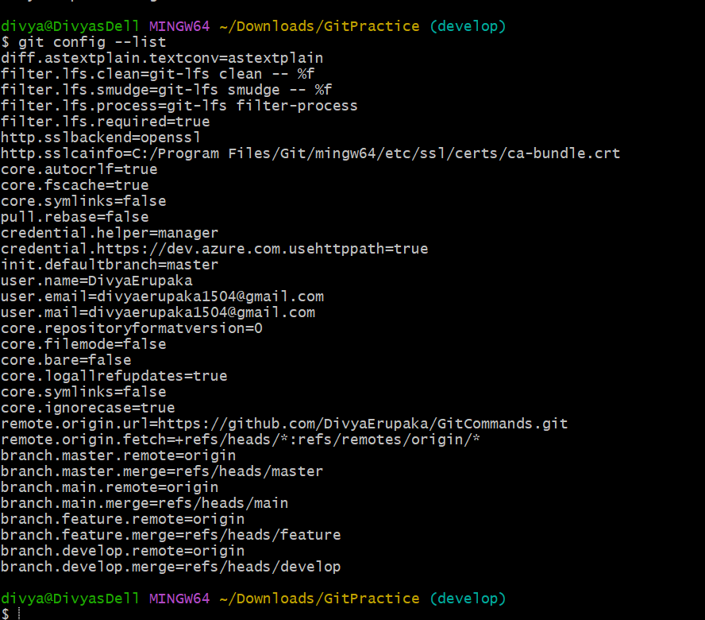
4. git config
Sets a specific configuration option
Step 1: Configure Default Branch
Example:
git config --global init.defaultBranch main
Outcome
Set default branch name to main.
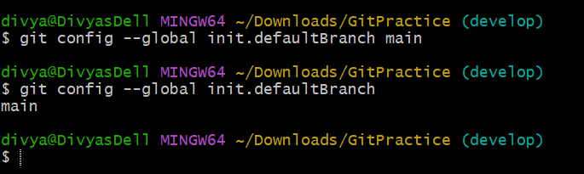
Step 2: Verify Configuration
git config --global init.defaultBranch
Expected Output
main
Outcome
Confirmed configuration applied.
5. git config --global core.editor
Sets default text editor for Git
Step 1: Configure VS Code as Editor
git config --global core.editor "code --wait"
Outcome
Configured VS Code as Git editor.
Step 2: Verify Editor
git config --global core.editor
Expected Output
code --wait
Outcome
Confirmed editor configuration.
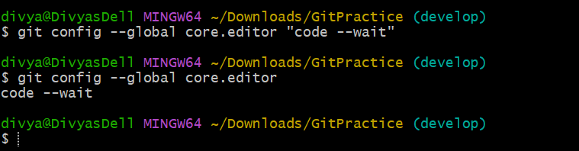
6. git config --global color.ui true
Enables colored Git output
Step 1: Enable Colored Output
git config --global color.ui true
Outcome
Enabled colored terminal output in Git.
Step 2: Verify Setting
git config --global color.ui
Expected Output
true
Outcome
Confirmed colored output enabled.
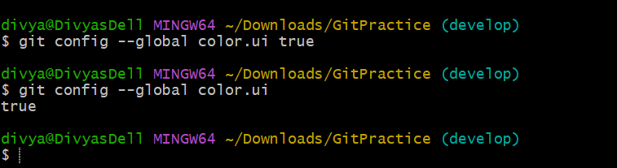
7. git config --global alias.st status
Creates Git alias
Step 1: Create Alias
git config --global alias.st status
Outcome
Created shortcut alias:
- git st
instead of:
- git status
Step 2: Use Alias
git st
Expected Output
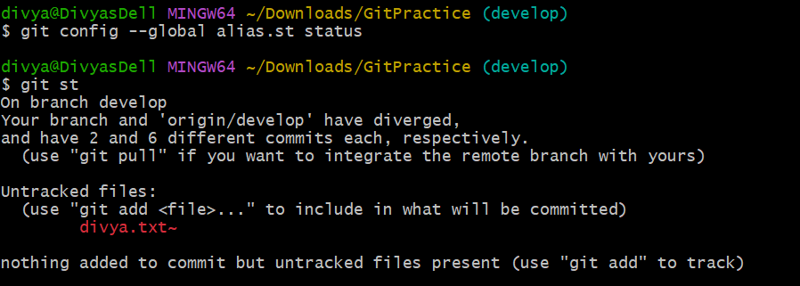
On branch develop
nothing to commit, working tree clean
Outcome
Verified alias works successfully.
Git Aliases (Custom commands)
git config --global alias.<alias_name>
<actual_command>: Creates a new Git alias for an existing command.
Example: git config --global alias.co checkout
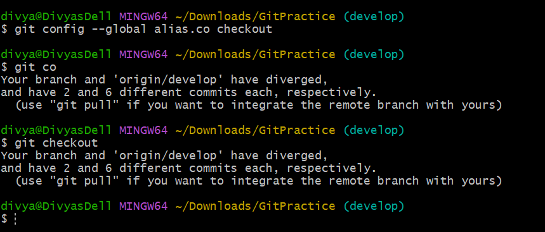
Git Hooks (Automated scripts triggered by Git actions)
Overview: Git hooks are scripts that run automatically at specific points in the Git workflow, such as:
- before a commit
- after a commit
- before a commit message is saved
They are stored inside:
.git/hooks/
1. git init: Creates a .git/hooks directory, where hook scripts are stored.
Creates Git repository (and .git/hooks folder)
Step 1: Create a project folder
mkdir HookDemo
cd HookDemo
Step 2: Initialize Git git init
Outcome
Initialized empty Git repository
Step 3: Verify hooks directory ls .git/hooks
Outcome You will see sample hook files like:
pre-commit.sample
commit-msg.sample
post-commit.sample
This confirms the hooks folder exists.
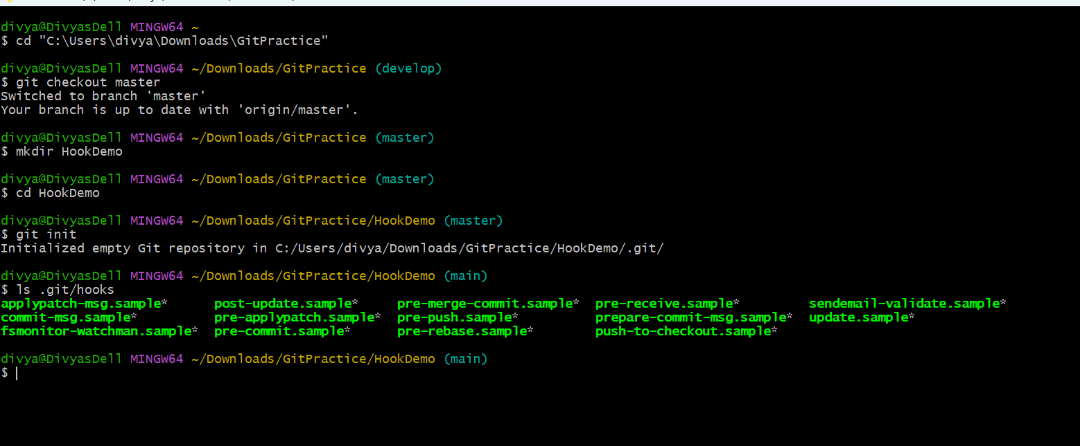
2. git commit-msg: A hook that runs before a commit message is saved (you can use this to enforce message formats).
Runs before commit message is saved
Purpose
Used to enforce commit message rules (example: must contain JIRA ID).
Step 1: Create hook file
touch .git/hooks/commit-msg
Step 2: Add script
nano .git/hooks/commit-msg
Add:
#!/bin/sh
msg=$(cat "$1")
if ! echo "$msg" | grep -q "JIRA-"
then
echo "ERROR: Commit message must contain JIRA-"
exit 1
fi
Step 3: Make it executable
chmod +x .git/hooks/commit-msg
Step 4: Test commit
Invalid commit
git commit -m "fix bug"
Output:
ERROR: Commit message must contain JIRA-
Valid commit
git commit -m "JIRA-101 fix bug"
Outcome: Commit is allowed only if rule is satisfied.
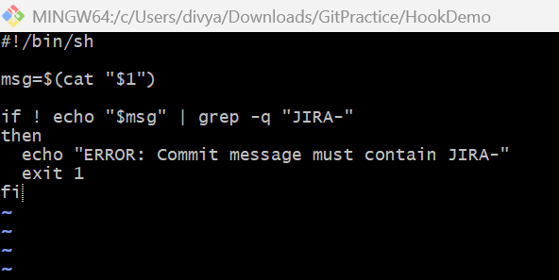
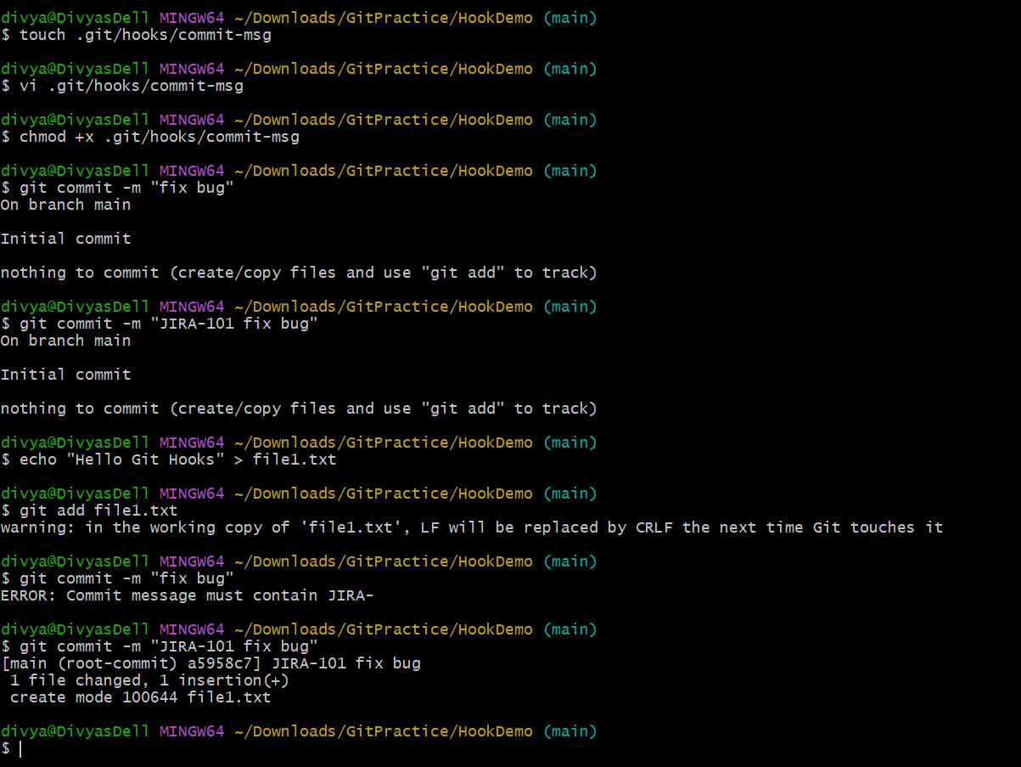
3. git pre-commit: A hook that runs before a commit is made (can be used for checks like linting).
Runs before commit is created
Purpose
Used for checks like:
- linting
- formatting
- tests
Step 1: Create hook
touch .git/hooks/pre-commit
Step 2: Add script
nano .git/hooks/pre-commit
Example:
#!/bin/sh
echo "Running pre-commit checks..."
# Example check
if git diff --cached --name-only | grep -q ".py"
then
echo "Python file detected - running checks..."
fi
Step 3: Make executable
chmod +x .git/hooks/pre-commit
Step 4: Test
git add .
git commit -m "JIRA-102 add feature"
Outcome
Running pre-commit checks...
Python file detected - running checks...
✔ Hook runs BEFORE commit is created.
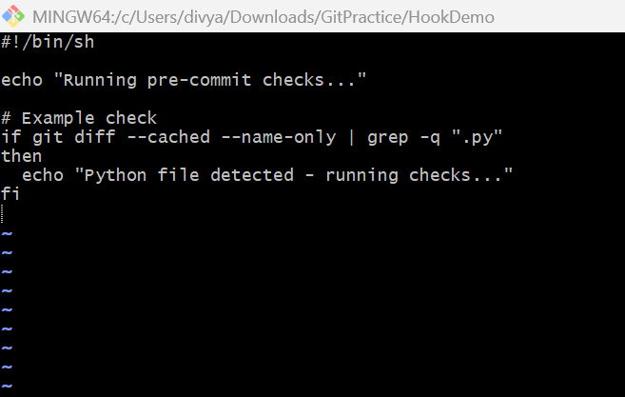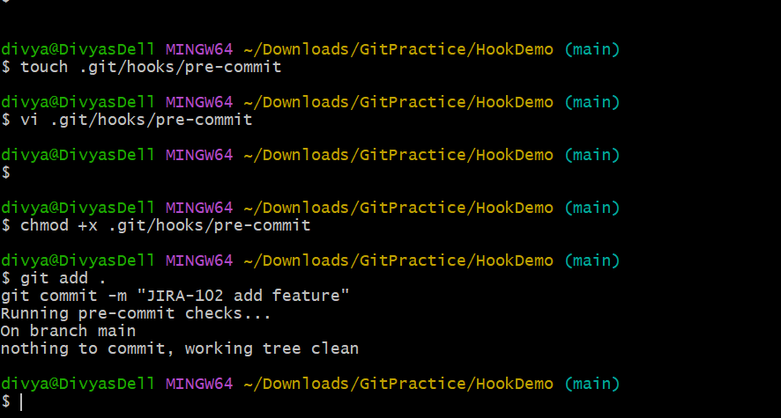
4. git post-commit: A hook that runs after a commit is made.
Runs after commit is completed
Purpose
Used for:
- notifications
- logs
- automation triggers
Step 1: Create hook : touch .git/hooks/post-commit
Step 2: Add script: vi .git/hooks/post-commit
Example:
#!/bin/sh
echo “Commit completed successfully!”
Step 3: Make executable
chmod +x .git/hooks/post-commit
Step 4: Test commit
git commit -m “JIRA-103 update file”
Output
Commit completed successfully!
Hook runs AFTER commit is done.
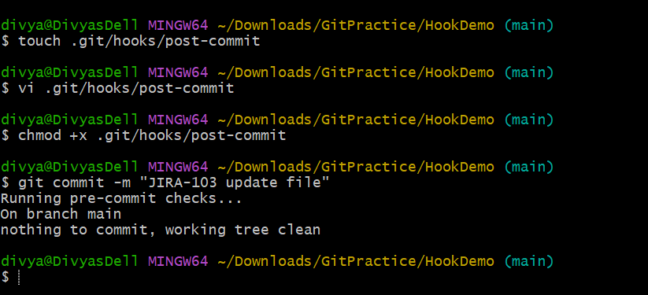
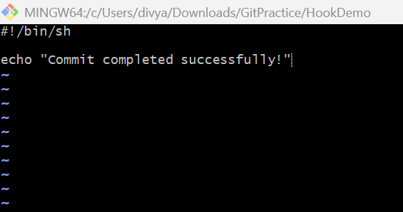
Summary Table
Hook | When it runs | Purpose
commit-msg | Before saving commit message | Validate message format
pre-commit | Before commit is created | Run checks (lint/test)
post-commit | After commit is completed | Notifications/logging
Git Submodules (Managing external repositories within a project)
Overview
Git submodules allow you to include one Git repository inside another Git repository.
They are used when:
- you want to reuse external projects
- you want to manage dependencies separately
- you want independent version control inside a main project
1. git submodule add <repo_url>: Adds a new submodule to the repository (downloads an external repo).
Adds a submodule to your repository
Step 1: Create main project
mkdir MainProject
cd MainProject
git init
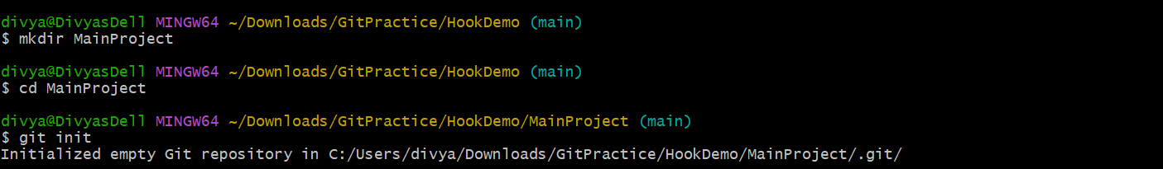
Step 2: Add submodule
git submodule add https://github.com/example/repo.git libs/repo
Outcome
- External repo downloaded into libs/repo
- .gitmodules file created
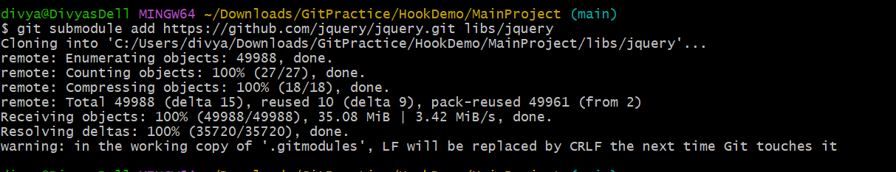
Step 3: Verify
ls
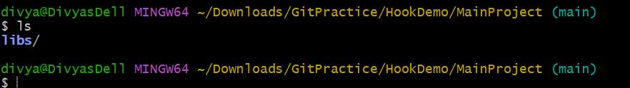
2. git submodule init: Initializes the submodules configured in the repository (after cloning).
Initializes submodule configuration
Step 1: After cloning project
git submodule init
Outcome
Reads .gitmodules and prepares submodules.
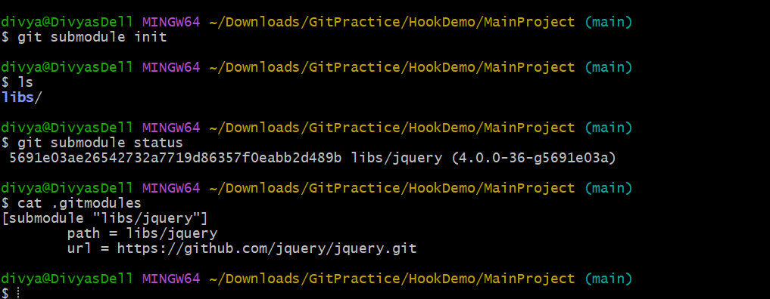
3. git submodule update: Updates the submodules to the commit specified in the superproject.
Downloads correct commit of submodule
Step 1: Update submodule
git submodule update
Outcome
- checks out correct commit inside submodule
- matches parent repository reference
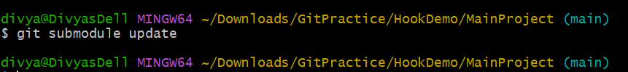

4. git submodule status: Displays the current commit of the submodule.
Shows current commit of submodules
Step 1: Check status
git submodule status
Example Output
a1b2c3 libs/repo (heads/main)
Outcome
Shows:
- commit hash
- submodule path
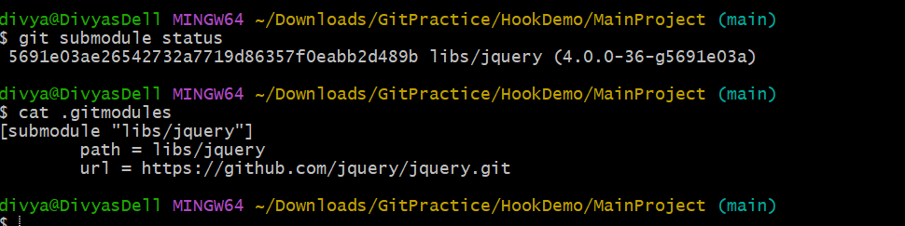
5. git submodule deinit: Removes a submodule from the working directory.
Removes submodule from working directory
Step 1: Deinitialize submodule
git submodule deinit libs/repo
Step 2: Remove working directory files
rm -rf libs/repo
Outcome
- submodule removed from working directory
- configuration still exists until fully cleaned
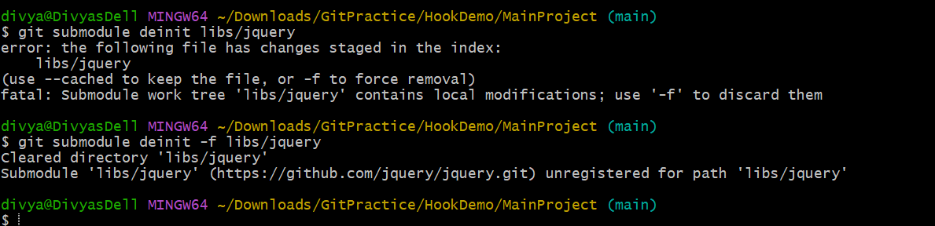
6. git submodule update --remote: Updates the submodule to the latest commit from the remote repository.
Updates submodule to latest commit from remote
Step 1: Fetch latest submodule changes
git submodule update --remote
Outcome
- pulls latest commit from submodule remote
- updates working copy
7. git submodule foreach: Runs a command in each submodule.
Runs command in every submodule
Step 1: Run command in all submodules
git submodule foreach 'git status'
Outcome
Runs git status inside each submodule.
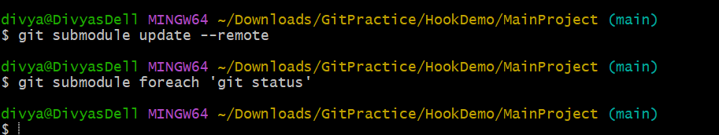
Summary Table
Command | Purpose
submodule add | Add external repo
submodule init | Initialize configuration
submodule update | Checkout correct commit
submodule status | Show commit info
submodule deinit | Remove submodule setup
submodule update --remote | Update to latest version
submodule foreach | Run command in all submodules
Git Workflow Commands (Working with others and managing collaboration)
1. git pull --rebase: Fetches and applies remote changes, rebasing your local commits on top of them.
Fetches remote changes and rebases local commits on top
Overview
Instead of creating a merge commit, this command:
- fetches latest remote changes
- reapplies your local commits on top
This creates a cleaner Git history.
Step 1: Check Branch Status
git status
Step 2: Pull with Rebase git pull --rebase origin develop
Expected Output
Successfully rebased and updated refs/heads/develop
Outcome
- latest remote changes fetched
- local commits replayed on top
- cleaner linear history maintained
Validation git log --oneline --graph
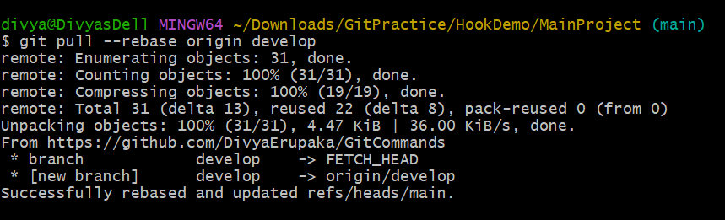
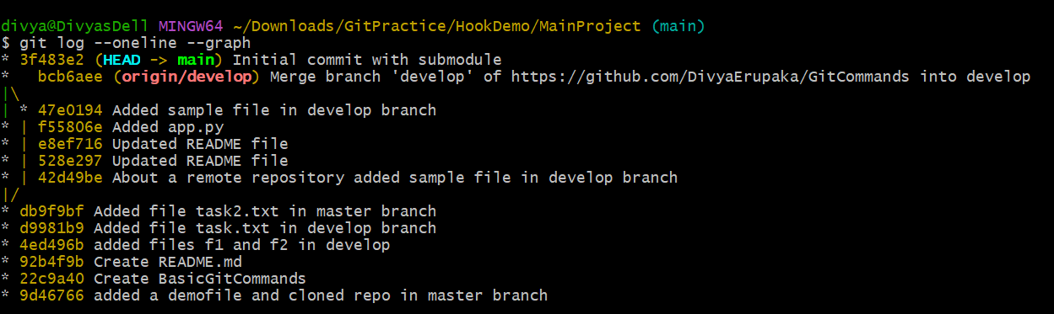
2. git rebase -i <commit_id>: Starts an interactive rebase to modify commit history (e.g., squash, reword commits).
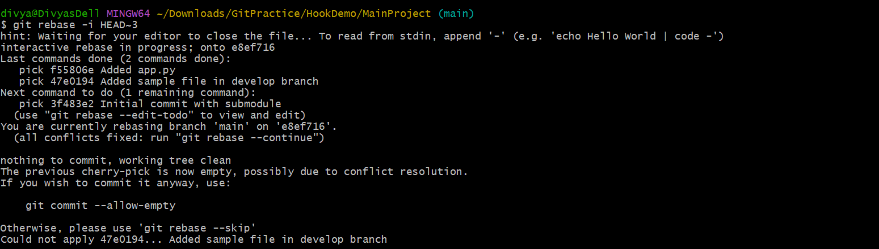
Git bisect (Finding the commit that introduced a bug)
Overview: git bisect helps identify the exact commit that introduced a bug using binary search.
Instead of checking every commit manually, Git automatically narrows down the problematic commit.
1.git bisect start
Starts the bisect process

Step 1: View Commit History
git log --oneline
Example:
f55806e Added app.py
db9f9bf Updated README
92b4f9b Initial setup
Step 2: Start Bisect: git bisect start
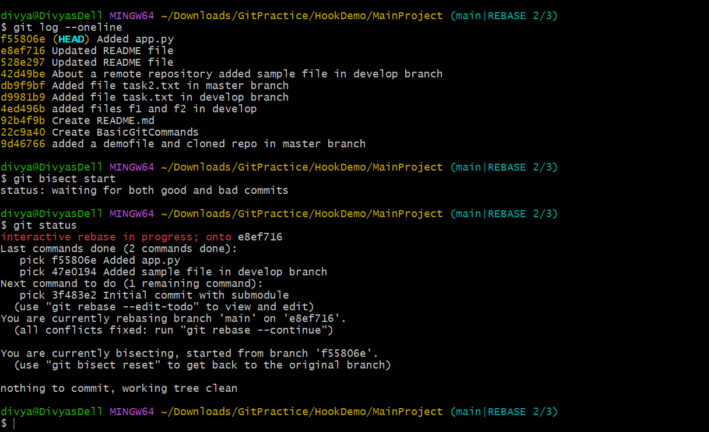
2. git bisect bad
git bisect bad
Marks current commit as bad
Scenario
Current commit contains bug.
Step 1: Mark Current Commit Bad
git bisect bad
Outcome
Git marks current commit as problematic.
Git automatically checks out another commit for testing.
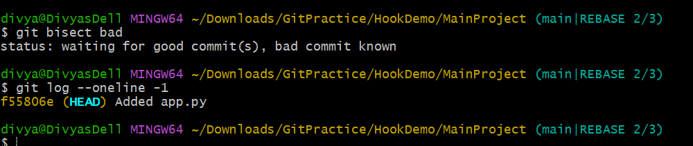
Validation
git log --oneline -1
3. git bisect good <commit_id>
Marks known working commit as good
1: Find Good Commit
git log --oneline
Example good commit:
92b4f9b Initial setup
Step 2: Mark Commit Good
git bisect good 92b4f9b
Outcome
Git narrows search range automatically.
What Happens Internally
Git performs binary search:
good ---------------- bad
^
test here
It checks intermediate commits automatically.
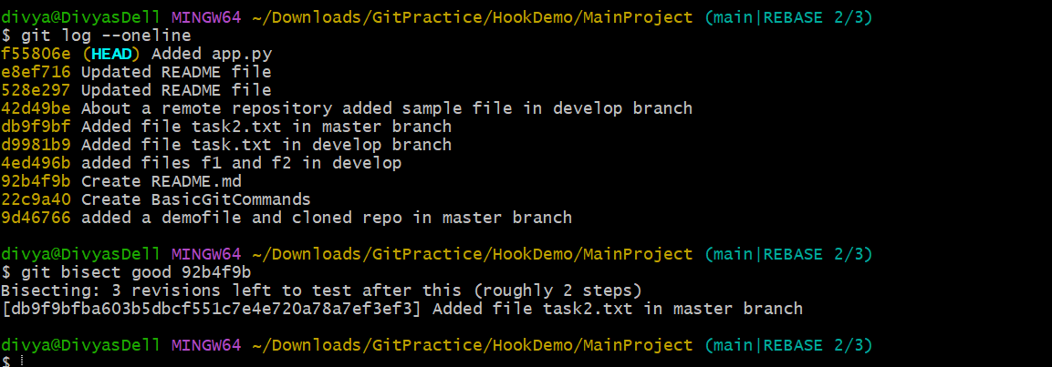
4. Continue Testing During Bisect
Step 1: Test Checked-Out Commit
Run project or tests manually.
Example:
python app.py
Step 2A: If Bug Exists
git bisect bad
Step 2B: If Bug Does NOT Exist
git bisect good
Outcome
Git continues narrowing down commits.
Final Result Example
f55806e is the first bad commit
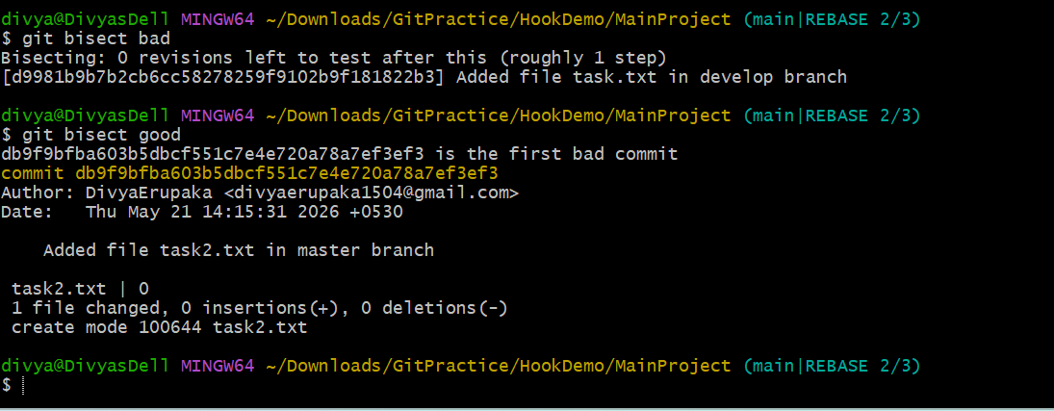

Summary Table
Command | Purpose
git bisect start | Start binary search
git bisect bad | Mark buggy commit
git bisect good | Mark working commit
git bisect reset | Exit bisect mode
git bisect log | Show bisect history

Git Hooks for Automation
Overview
Git hooks are scripts that run automatically during Git events like:
- commit
- push
- merge
Hooks are stored inside:
.git/hooks/

Common Hooks
Hook | Trigger Time
commit-msg | Before commit message finalized
pre-commit | Before commit happens
post-commit | After commit completes
pre-push | Before pushing to remote
post-merge | After merge completes
1. git commit-msg
Validates commit messages
Objective
Enforce rules like:
- commit must contain JIRA ticket
- no short messages
Step 1: Create Hook File
touch .git/hooks/commit-msg
Step 2: Open File
vi .git/hooks/commit-msg
Step 3: Add Script
#!/bin/sh
msg=$(cat "$1")
if ! echo "$msg" | grep -q "JIRA-"
then
echo "ERROR: Commit message must contain JIRA-"
exit 1
fi
Step 4: Make Executable
chmod +x .git/hooks/commit-msg
Step 5: Test Invalid Commit
git commit -m "fixed bug"
Expected:
ERROR: Commit message must contain JIRA-
Step 6: Test Valid Commit
git commit -m "JIRA-101 fixed bug"
Outcome
Commit message validated automatically.
2. git pre-commit
Runs checks before commit
Objective
Prevent bad commits:
- lint failures
- test failures
- formatting issues
Step 1: Create Hook
touch .git/hooks/pre-commit
Step 2: Add Script
#!/bin/sh
echo "Running pre-commit checks..."
python -m py_compile app.py
if [ $? -ne 0 ]
then
echo "Python syntax error detected"
exit 1
fi
Step 3: Make Executable
chmod +x .git/hooks/pre-commit
Step 4: Commit Code
git commit -m "Added app"
Outcome
Commit blocked if syntax error exists.
3. git post-commit
Runs after commit completes
Objective
Trigger:
- notifications
- logging
- builds
Step 1: Create Hook
touch .git/hooks/post-commit
Step 2: Add Script
#!/bin/sh
echo "Commit completed successfully"
Step 3: Make Executable
chmod +x .git/hooks/post-commit
Step 4: Commit Changes
git commit -m "Updated task"
Outcome
Message appears after successful commit.
4. git pre-push
Runs before push operation
Objective
Prevent pushing broken code.
Step 1: Create Hook
touch .git/hooks/pre-push
Step 2: Add Script
#!/bin/sh
echo "Running tests before push..."
Step 3: Make Executable
chmod +x .git/hooks/pre-push
Step 4: Push Code
git push origin main
Outcome
Hook executes before push starts.
5. git post-merge
Runs after merge operation
Objective
Perform:
- cleanup
- dependency installation
- environment setup
Step 1: Create Hook
touch .git/hooks/post-mergeStep 2: Add Script
#!/bin/sh
echo "Merge completed"
Step 3: Make Executable
chmod +x .git/hooks/post-mergeStep 4: Merge Branch
git merge develop
Outcome
Hook executes after merge finishes.
Git Blame and Annotate (Tracing the history of file content)
Overview: git blame and git annotate help trace:
- who modified a line
- when it was modified
- which commit introduced the change
These commands are useful for:
- debugging
- tracking changes
- understanding code history
1. git blame <file_path>
Shows line-by-line modification history
Objective
Identify:
- author
- commit ID
- modification date
for each line in a file.
Step 1: Check Repository Files
Example from your repository:
ls
Example output:
README.md app.py task.txt
Step 2: Run Git Blame
Example:
git blame app.py
Example Output
f55806e (Divya 2026-05-22 10:15:20 +0530 1) print("Hello")
92b4f9b (Divya 2026-05-21 09:00:10 +0530 2) print("Git Practice")
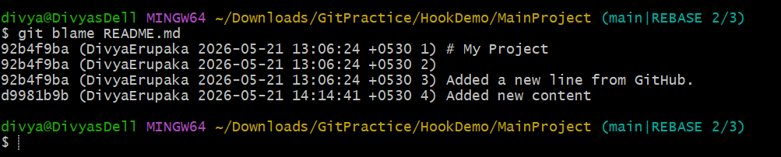
Output Explanation
Part | Meaning
f55806e | Commit ID
Divya | Author
2026-05-22 | Modification date
1 | Line number
print("Hello") | Actual code
2. git annotate <file_path>
Alias for git blame
Overview
git annotate behaves similarly to git blame.
Step 1: Run Annotate
git annotate app.py
Example Output
f55806e (Divya 2026-05-22 10:15:20 +0530 1) print("Hello")
92b4f9b (Divya 2026-05-21 09:00:10 +0530 2) print("Git Practice")
Outcome
Displayed:
- line-by-line commit history
- author details
- timestamps
Validation : git show 92b4f9b
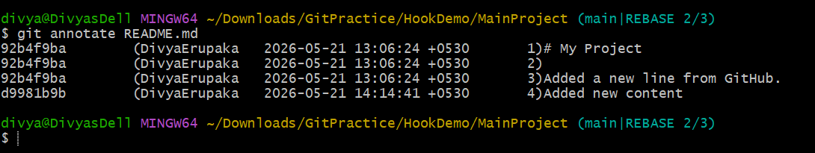
Difference Between Blame and Annotate
Command | Purpose
git blame | Standard command
git annotate | Alias of blame
Functionality is almost identical.
Git Reflog (Tracking changes in the HEAD reference)
1. git reflog: Displays a log of all movements of the HEAD pointer (useful for tracking changes like reset and rebase operations).
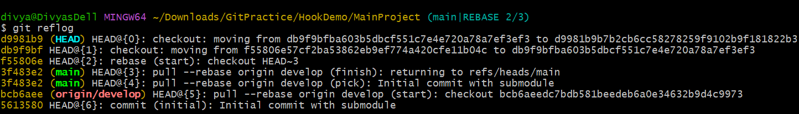
2. git reflog show: Displays a detailed view of HEAD and the state of the repository.
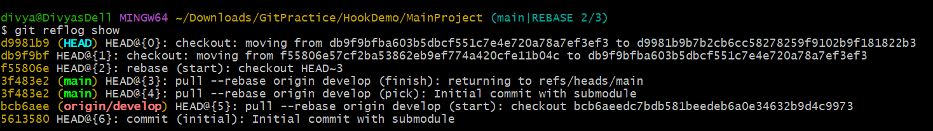
3. git reflog expire --expire=now --all: Removes all reflog entries that have expired.
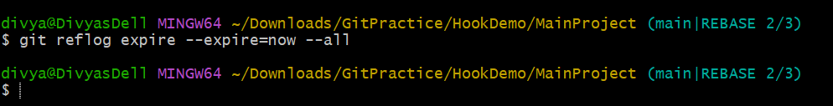
4. git reflog delete <ref_id>: Deletes a specific reflog entry.
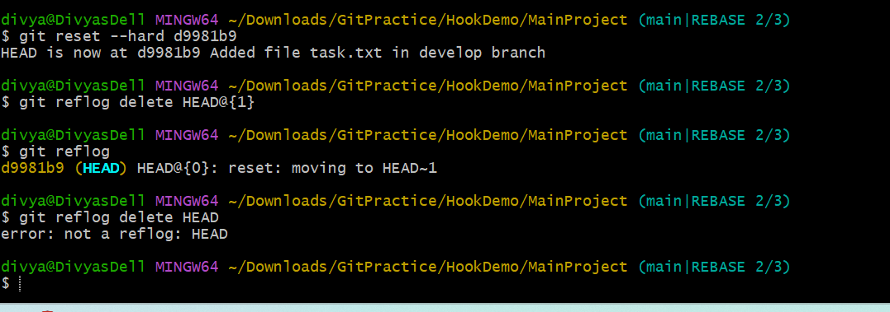
Summary Table
Command | Purpose
git reflog | Show HEAD movement history
git reflog show | Detailed reflog view
git reflog expire | Remove expired entries
git reflog delete | Delete specific entry

